

Description of 6C7 Message

PIP® 6C7
Validated 11.00.00

Specification Information
Name | Description Of 6C7 Message
PIP | Notify of Warranty Claim Request
Cluster | Service and Support
Segment | Technical Support & Service Management
Publication Date | 10 March 2010
Version Identifier | V11.00

Table of Content
1. Document Management 5
1.1 Legal Disclaimer 5
1.2 Copyright 5
1.3 Trademarks 5
1.4 Acknowledgments 5
1.5 Related Documents 5
1.6 Document Version History 5
1.7 Document Purpose 5
2. Interchange Model 6
2.1 WarrantyClaimRequestNotification 6
2.1.1 Interchange Diagram 6
2.1.2 Dependency Diagram 6
2.1.3 ServicedUnit 7
2.1.4 ServiceEvent 8
2.1.5 WarrantyClaimRequest 9
2.1.6 WarrantyClaimRequestData 10
3. Domain Model 11
3.1 Service 11
3.1.1 Dependency Diagram 11
3.1.2 FailureAnalysis 12
3.1.3 FailureInformation 13
3.1.4 PurchaseDate 13
3.1.5 ServiceCompletionDate 14
3.1.6 ServiceStartDate 14
3.1.7 CodeList 15
3.1.7.1 ClaimStatus 15
3.1.7.2 ClaimType 15
3.1.7.3 FailureAction 15
3.1.7.4 FailureModifier 15
3.1.7.5 FailureObservedCondition 16
3.1.7.6 OperatingSystem 18
3.1.7.7 ServiceDeliveryMethod 18
3.2 Shared 19
3.2.1 Dependency Diagram 19
3.2.2 CodeList 20
3.2.2.1 WarrantyType 20
4. Universal Structure 21
4.1 ContactInformation 21
4.1.1 ContactInformation 21
4.2 DataType 22
4.2.1 Contact 22
4.2.2 DUNS 22
4.2.3 DUNSPlus4 23
4.2.4 GLN 23
4.2.5 GTIN 24
4.3 Document 25
4.3.1 BusinessDocumentReference 25
4.4 Locations 26
4.4.1 AlternativeIdentifier 26
4.4.2 Location 27
4.4.3 LocationChoice 28
4.4.4 PhysicalAddress 29
4.5 PartnerIdentification 31
4.5.1 PartnerIdentification 31
4.5.2 PartnerIdentificationChoice 32
4.5.3 SpecifiedFullPartner 33
4.5.4 SpecifiedIntermittentPartner 34
4.5.5 SpecifiedKnownPartner 35
4.5.6 SpecifiedKnownPartnerContact 35
4.5.7 SpecifiedNewPartner 36
4.5.8 SpecifiedPartnerDescription 37
4.5.9 SpecifiedPartnerDescriptionChoice 38
4.6 ProductIdentification 39
4.6.1 ProductIdentification 39
4.6.2 ProductIdentificationChoice 39
4.6.3 ProductSerialIdentification 40
4.7 CodeList 41
4.7.1 Country 41
4.7.2 CountrySubdivision 41
4.7.3 Language 41
4.7.4 DocumentType 42
4.7.5 MimeTypeQualifier 44
5. System Structure 55
5.1 BusinessProcessIdentifier 55
5.2 BusinessServiceInformation 56
5.3 ContractInformation 57
5.4 CorrelationInformation 57
5.5 DocumentHeader 58
5.6 DocumentIdentification 59
5.7 DocumentIdentificationChoice 59
5.8 DocumentInformation 60
5.9 DocumentManifest 61
5.10 DocumentSecurity 62
5.11 ManifestItem 63
5.12 PipIdentifier 64
5.13 PipVersion 64
5.14 Receiver 65
5.15 RequestingDocumentInformation 66
5.16 Sender 67
5.17 StandardDocumentIdentification 68
5.18 TpirPipIdentification 69
5.19 VersionIdentifier 70
5.20 CodeList 70
5.20.1 TPIRFileType 70
6. XML Data Type 71
6.1 anyURI 71
6.2 boolean 71
6.3 dateTime 71
6.4 positiveInteger 71
6.5 string 71

Table of Figures
Figure ‎2-1 Interchange 6
Figure ‎2-2 Dependency 6
Figure ‎2-3 ServicedUnit 7
Figure ‎2-4 ServiceEvent 8
Figure ‎2-5 WarrantyClaimRequest 9
Figure ‎2-6 WarrantyClaimRequestData 10
Figure ‎3-1 Dependency 11
Figure ‎3-2 FailureAnalysis 12
Figure ‎3-3 FailureInformation 13
Figure ‎3-4 PurchaseDate 13
Figure ‎3-5 ServiceCompletionDate 14
Figure ‎3-6 ServiceStartDate 14
Figure ‎3-7 Dependency 19
Figure ‎4-1 ContactInformation 21
Figure ‎4-2 Contact 22
Figure ‎4-3 DUNS 22
Figure ‎4-4 DUNSPlus4 23
Figure ‎4-5 GLN 23
Figure ‎4-6 GTIN 24
Figure ‎4-7 BusinessDocumentReference 25
Figure ‎4-8 AlternativeIdentifier 26
Figure ‎4-9 Location 27
Figure ‎4-10 PhysicalAddress 29
Figure ‎4-11 PartnerIdentification 31
Figure ‎4-12 SpecifiedFullPartner 33
Figure ‎4-13 SpecifiedIntermittentPartner 34
Figure ‎4-14 SpecifiedKnownPartner 35
Figure ‎4-15 SpecifiedKnownPartnerContact 35
Figure ‎4-16 SpecifiedNewPartner 36
Figure ‎4-17 SpecifiedPartnerDescription 37
Figure ‎4-18 ProductIdentification 39
Figure ‎4-19 ProductSerialIdentification 40
Figure ‎5-1 BusinessProcessIdentifier 55
Figure ‎5-2 BusinessServiceInformation 56
Figure ‎5-3 ContractInformation 57
Figure ‎5-4 CorrelationInformation 57
Figure ‎5-5 DocumentHeader 58
Figure ‎5-6 DocumentIdentification 59
Figure ‎5-7 DocumentInformation 60
Figure ‎5-8 DocumentManifest 61
Figure ‎5-9 DocumentSecurity 62
Figure ‎5-10 ManifestItem 63
Figure ‎5-11 PipIdentifier 64
Figure ‎5-12 PipVersion 64
Figure ‎5-13 Receiver 65
Figure ‎5-14 RequestingDocumentInformation 66
Figure ‎5-15 Sender 67
Figure ‎5-16 StandardDocumentIdentification 68
Figure ‎5-17 TpirPipIdentification 69
Figure ‎5-18 VersionIdentifier 70

Document Management

Legal Disclaimer
RosettaNet, its members, officers, directors, employees, or agents shall not be liable for any injury, loss, damages, financial or otherwise, arising from, related to, or caused by the use of this document or the specifications herein, as well as associated guidelines and schemas. The use of said specifications shall constitute your express consent to the foregoing exculpation.

Copyright
©2010 RosettaNet. All rights reserved. No part of this publication may be reproduced, stored in a retrieval system, or transmitted, in any form or by any means, electronic, mechanical, photocopying, recording, or otherwise, without the inclusion of this copyright notice. Any derivative works must cite the copyright notice. Any public redistribution or sale of this publication or derivative works requires prior written permission of the publisher.

Trademarks
RosettaNet, Partner Interface Process, PIP and the RosettaNet logo are trademarks or registered trademarks of "RosettaNet," a non-profit organization. All other product names and company logos mentioned herein are the trademarks of their respective owners. In the best effort, all terms mentioned in this document that are known to be trademarks or registered trademarks have been appropriately recognized in the first occurrence of the term.

Acknowledgments
This document has been prepared by RosettaNet (http://www.rosettanet.org/) from requirements gathered during the Milestone Program and in conformance with the methodology.

Related Documents
- Associated PIP Message Schemas (included with PIP Specification only)
- Description of Partner Interface Process for 6C7
- Message Structure

Document Version History
Version | Date | Description
Validated 11.00.00 | 10 March 2010 | Validated Version : MCC Program

Document Purpose
The purpose of the document is to explain the structure, the association between objects, the content of objects and the definition for single elements to a non-technical audience.

Interchange Model

WarrantyClaimRequestNotification

Interchange Diagram
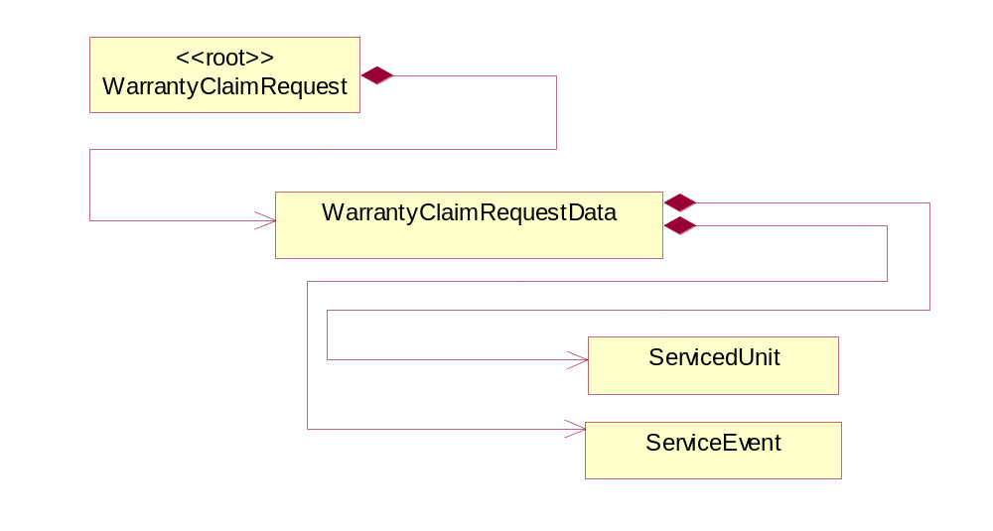
Figure ‎2-1 Interchange

Dependency Diagram
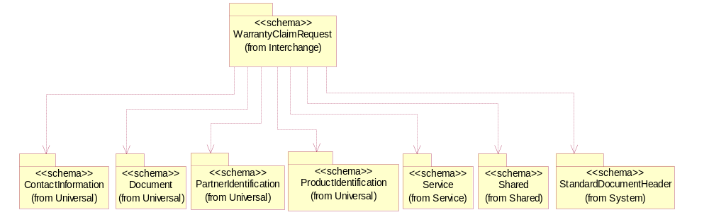
Figure ‎2-2 Dependency

ServicedUnit
The collection of data elements that describes the unit for which service was provided.
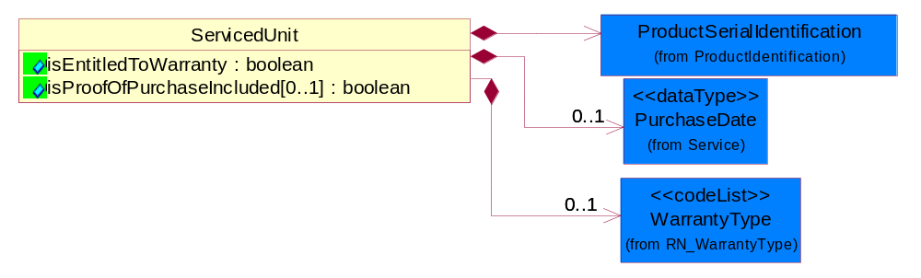
Figure ‎2-3 ServicedUnit

Attribute | Type | Documentation
isEntitledToWarranty | boolean | Indicates whether or not the particulary warranty type is covered.
isProofOfPurchaseIncluded[0..1] | boolean | An indicator to show if evidence of purchase accompanies this claim.

Composition | Cardinality | Type | Documentation
ProductSerialIdentification | 1 | ProductSerialIdentification | The object provides the serial identifier of a product.
PurchaseDate | 0..1 | PurchaseDate | Date of purchase of a unit.
WarrantyType | 0..1 | WarrantyType | The classification of each warranty coverage type that can be claimed.

ServiceEvent
The collection of data that comprises a service.
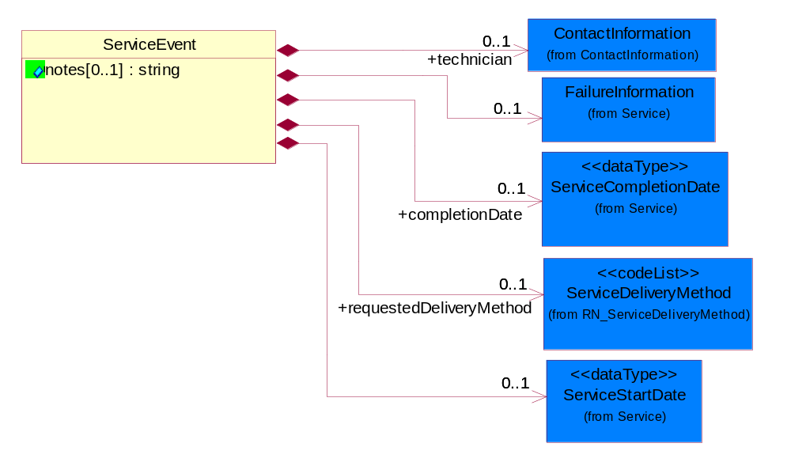
Figure ‎2-4 ServiceEvent

Attribute | Type | Documentation
notes[0..1] | string | A text field that contains information related to a service event.

Composition | Cardinality | Type | Documentation
requestedDeliveryMethod | 0..1 | ServiceDeliveryMethod | The service delivery method suggested by the ASP to deliver the warranty entitilement on a unit.
technician | 0..1 | ContactInformation | Collection of data entiities that identify the person who performed the warranty service.
completionDate | 0..1 | ServiceCompletionDate | Date Warranty Service was completed on a unit.
ServiceStartDate | 0..1 | ServiceStartDate | Date Warranty Service was begun on a unit.
FailureInformation | 0..1 | FailureInformation | The collection of data entities that comprise information regarding the failure of a product being returned to a provider or supplier.

WarrantyClaimRequest
A message wrapper for the PIP6C2.
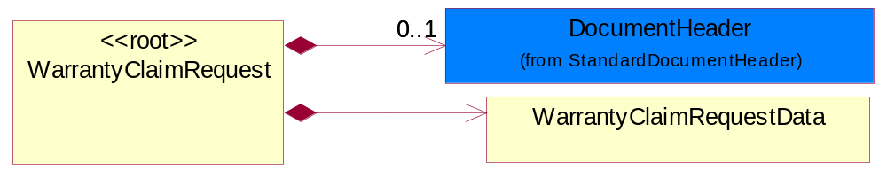
Figure ‎2-5 WarrantyClaimRequest

Composition | Cardinality | Type | Documentation
DocumentHeader | 0..1 | DocumentHeader | The object allows for the identification of the sender and receiver of the business document.
WarrantyClaimRequestData | 1 | WarrantyClaimRequestData | Collection of data entities that comprise the claim request.

WarrantyClaimRequestData
Collection of data entities that comprise the claim request.
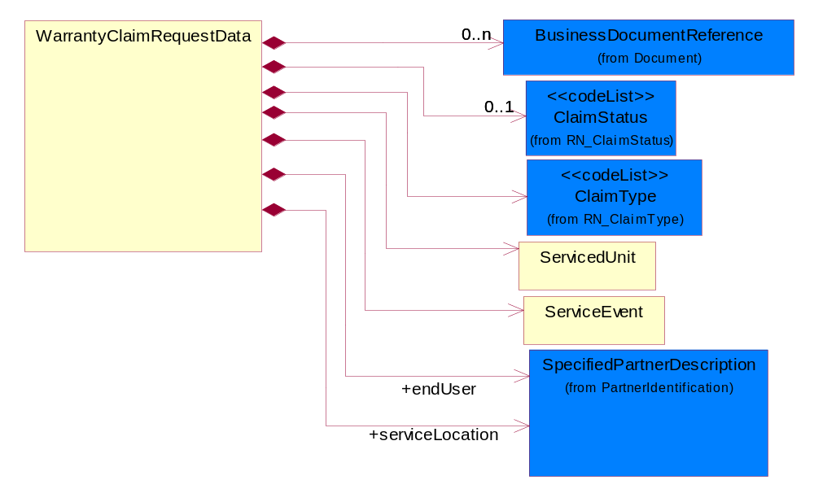
Figure ‎2-6 WarrantyClaimRequestData

Composition | Cardinality | Type | Documentation
BusinessDocumentReference | 0..n | BusinessDocumentReference | The business document reference object allows for the indirect referencing of a relationship to other business related documents.
ClaimStatus | 0..1 | ClaimStatus | Code that denotes the current status of a Warranty Claim.
ClaimType | 1 | ClaimType | Codes used to define the type of service claim being requested.
ServicedUnit | 1 | ServicedUnit | The collection of data elements that describes the unit for which service was provided.
ServiceEvent | 1 | ServiceEvent | The collection of data that comprises a service.
endUser | 1 | SpecifiedPartnerDescription | Used to reference the contct information for an end user of a serviced unit.
serviceLocation | 1 | SpecifiedPartnerDescription | The address where warranty service was performed.

Domain Model

Service

Dependency Diagram
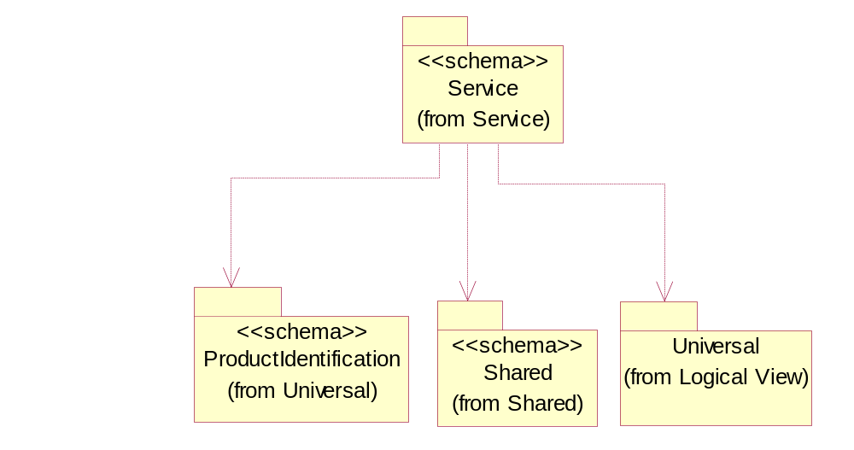
Figure ‎3-7 Dependency

FailureAnalysis
The collection of codes that describe a product failure.

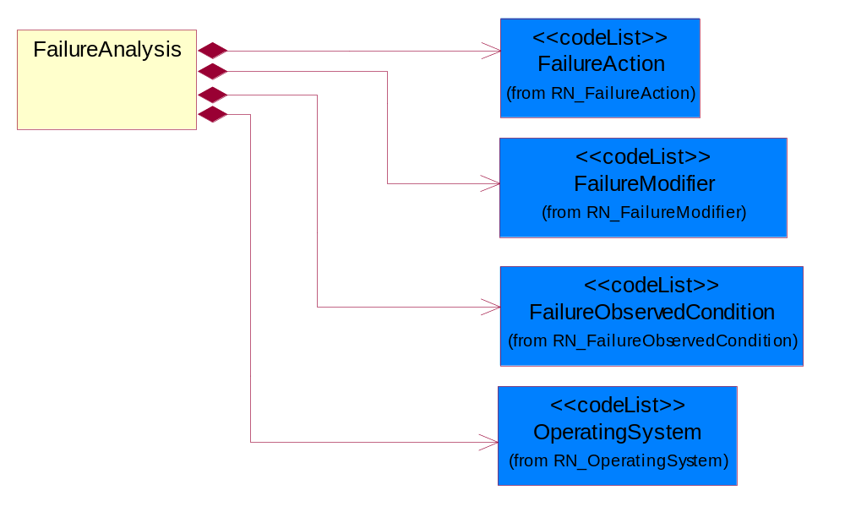
Figure ‎3-8 FailureAnalysis

Composition | Cardinality | Type | Documentation
FailureModifier | 1 | FailureModifier | The code used to describe the frequency or source of an operating system error.
FailureAction | 1 | FailureAction | The code used to describe the action taken to resolve an operating system error.
OperatingSystem | 1 | OperatingSystem | Used to define the computer operating system.
FailureObservedCondition | 1 | FailureObservedCondition | The code used to describe the nature of a system error.

FailureInformation
The collection of data entities that comprise information regarding the failure of a product being returned to a provider or supplier.

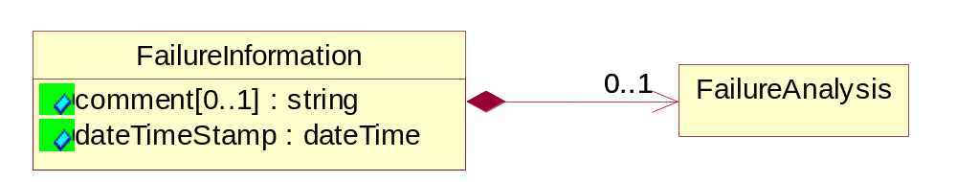
Figure ‎3-9 FailureInformation

Attribute | Type | Documentation
comment[0..1] | string | Text field used to further describe the suspected or observed conditions that caused a failue in a returned product.
dateTimeStamp | dateTime | Captures the date of failure of a product.

Composition | Cardinality | Type | Documentation
FailureAnalysis | 0..1 | FailureAnalysis | The collection of codes that describe a product failure.

PurchaseDate
Date of purchase of a unit.
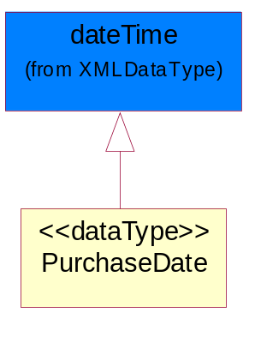
Figure ‎3-10 PurchaseDate

ServiceCompletionDate
Date Warranty Service was completed on a unit.
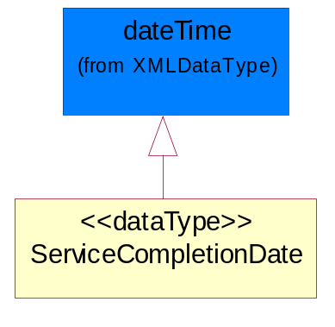
Figure ‎3-11 ServiceCompletionDate

ServiceStartDate
Date Warranty Service was begun on a unit.
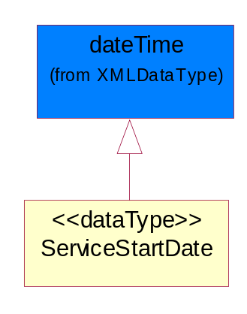
Figure ‎3-12 ServiceStartDate

CodeList

ClaimStatus
Code that denotes the current status of a Warranty Claim.
Name | Documentation
CAN | Cancel - The claim has been cancelled.
CLO | Close - Close the referenced warranty claim without further action.
COM | Complete - The claim has been processed.
INC | Incomplete - All required fields for the claim have not been completed.
OPE | Open - Open a new warranty claim.
UPD | Update- Referenced warranty claim information is updated by this message.
VOI | Void - The claim has been voided.

ClaimType
Codes used to define the type of service claim being requested.
Name | Documentation
OOW | Out of Warranty.
OPT | Options.
SPA | Spare Parts.
UNI | Unit.

FailureAction
The code used to describe the action taken to resolve an operating system error.
Name | Documentation
CON | Configure - CompTIA code f.
NAC | No Action - CompTIA code d.
REA | Readjust - CompTIA code b.
REL | Reload - CompTIA code e.
RES | Reseat - CompTIA code c.
RET | Return - CompTIA code a.

FailureModifier
The code used to describe the frequency or source of an operating system error.

Name | Documentation
CON | Configuration - CompTIA code f.
COO | Continuous - CompTIA code b.
DAM | Damaged - CompTIA code g.
ENV | Environmental - CompTIA code e.
FAW | Fails After Warmup - CompTIA code d.
INT | Intermittent - CompTIA code c.
NAP | Not Applicable - CompTIA code a.

FailureObservedCondition
The code used to describe the nature of a system error.

Name | Documentation
BNR | Boards - Will Not Run Off AC Power. See also CompTIA Code: 525
BSU | Boards - Set Up. See also CompTIA Code: 512
BTD | Boards - Tape Drive Error. See also CompTIA Code: 506
BVE | Boards - Video Error. See also CompTIA Code: 505
BWB | Boards - Wrong Beeps/Startup Tone. See also CompTIA Code: 513
DAC | Display - Cannot Adjust Contrast. See also CompTIA Code: 213
DAD | Drives - Disks Do not Work in Another Drive. See also CompTIA Code: 311
DBR | Drives - Will Not Boot,Read & Writes OK. See also CompTIA Code: 312
DBS | Drives - Bad Sectors. See also CompTIA Code: 307
DCM | Display - Color(s) Missing. See also CompTIA Code: 206
DDS | Display - Diagonal Stripe. See also CompTIA Code: 210
DFC | Display - Focus/Converge. See also CompTIA Code: 203
DFE | Drives - Format Error. See also CompTIA Code: 304
DFS | Display - Fan Not Spinning. See also CompTIA Code: 211
DHB | Display - Horizontal/Vertical Bright Lines. See also CompTIA Code: 208
DID | Drives - I.D. Error. See also CompTIA Code: 305
DIP | Display - Incorrect Picture Size/Alignment. See also CompTIA Code: 216
DIS | Drives - Internal Or Will Not Spin. See also CompTIA Code: 302
DLI | Display - Dim or Low Intensity. See also CompTIA Code: 215
DLR | Drives - Lost Records. See also CompTIA Code: 306
DNA | Drives - Will Not Accept Disk. See also CompTIA Code: 310
DNB | Display - No Back Light. See alsoCompTIA Code: 205
DNM | Drives - Drive Will Not Mount. See also CompTIA Code: 308
DNR | Drives - Not Recognized w/Utility or Formatter. See also CompTIA Code: 309
DNS | Display - Would Not Show 2nd Monitor. See also CompTIA Code: 217
DNV | Display - Display-No Video. See also CompTIA Code: 201
DNY | Drives - Noisy. See also CompTIA Code: 301
DPC | Display - Pin Cushioning. See also CompTIA Code: 207
DPR | Display - Poor Resolution. See alsoCompTIA Code: 204
DRC | Display - Random Characters on Display. See also CompTIA Code: 214
DRV | Display - Rolls Vertically. See also CompTIA Code: 209
DRW | Drives - Read/Write Error. See also CompTIA Code: 303
DTS | Display - Distorted Sound. See also CompTIA Code: 212
DUV | Display - Unstable Video(Jitter/Flicker). See also CompTIA Code: 202
IDC | Input Devices - Bad Cord/Cable. See also CompTIA Code: 409
IDF | Input Devices - Foreign Substance Spilled on Unit. See also CompTIA Code: 405
IDI | Input Devices - Inoperative Key. See also CompTIA Code: 403
IDJ | Input Devices - Jittery/Intermittent. See also CompTIA Code: 407
IDK | Input Devices - Incorrect Key Code. See also CompTIA Code: 404
IDL | Input Devices - Locks Up. See also CompTIA Code: 401
IDM | Input Devices - Mechanical Failure. See also CompTIA Code: 408
IDR | Input Devices - No Response - Logic Board OK. See also CompTIA Code: 411
IDS | Input Devices - Sticky Key. See also CompTIA Code: 402
IDT | Input Devices - Not Tracking Properly. See also CompTIA Code: 406
IDU | Input Devices - Locks Up System. See also CompTIA Code: 410
MCF | Modems - Communication Failures. See also CompTIA Code: 902
MDA | Multi-Function Devices - Accessories. See also CompTIA Code: 801
MDC | Multi-Function Devices - Configuration. See also CompTIA Code: 802
MSB | Miscellaneous - Will Not Boot From HDD. See also CompTIA Code: 103
MSC | Miscellaneous - Cosmetic. See also CompTIA Code: 108
MSD | Miscellaneous - Damaged. See also CompTIA Code: 105
MSG | Miscellaneous - Good Part. CompTIA Code 101.
MSH | Miscellaneous - Hibernation / Sleep Problem. See also CompTIA Code: 111
MSI | Miscellaneous - Intermittent. See also CompTIA Code: 107
MSM | Miscellaneous - Mechanical. See also CompTIA Code: 104
MSP | Miscellaneous - No Power/No Light. See also CompTIA Code: 102
MSR | Miscellaneous - Reset Problem. See also CompTIA Code: 110
MSS | Miscellaneous - Screen Bright, No MAC Face. See also CompTIA Code: 109
MST | Modems - Self-Test Fails. See also CompTIA Code: 901
MSU | Miscellaneous - System Hangs Up. See also CompTIA Code: 106
PFA | Printer/Fax - Accesories. See also CompTIA Code: 703
PFB | Printer/Fax - Select Button Inoperable. See also CompTIA Code: 711
PFC | Printer/Fax - Communications. See also CompTIA Code: 707
PFE | Printer/Fax - Scanner. See also CompTIA Code: 706
PFF | Printer/Fax - Fails Self Test. See also CompTIA Code: 712
PFH | Printer/Fax - Paper Handling. See also CompTIA Code: 702
PFI | Printer/Fax - Indicator Lights Suggest Fault. See also CompTIA Code: 713
PFL | Printer/Fax - No Power Light. See also CompTIA Code: 709
PFM | Printer/Fax - Improper Print Head Movement. See also CompTIA Code: 710
PFN | Printer/Fax - Printer Not Seen By CPU. See also CompTIA Code: 714
PFO | Printer/Fax - Overheating. See also CompTIA Code: 704
PFP | Printer/Fax - PCB. See also CompTIA Code: 705
PFQ | Printer/Fax - Print Quality(include sample). See also CompTIA Code: 701
PFS | Printer/Fax - Software. See also CompTIA Code: 708
PSB | Power Supply - Blows Fuses. See also CompTIA Code: 606
PSC | Power Supply - Crowbar/Chirping. See also CompTIA Code: 605
PSF | Power Supply - Causes System Failures. See also CompTIA Code: 607
PSN | Power Supply - Noise/Hum. See also CompTIA Code: 604
PSO | Power Supply - Overheat(Fan Problem). See also CompTIA Code: 601
PSP | Power Supply - UPS Power - On Indicator Not Lit. See also CompTIA Code: 609
PSR | Power Supply - Random Reset. See also CompTIA Code: 602
PSU | Power Supply - UPS Battery Replacement Indicated. See also CompTIA Code: 608
PSV | Power Supply - Voltage Missing. See also CompTIA Code: 603

OperatingSystem
Used to define the computer operating system.

Name | Documentation
BAN | Banyan - Banyan NetworkOperating System - any version - CompTIA Code H.
DOS | Disk Operating System - CompTIA Code B.
NAP | Not Applicable - CompTIA Code A.
NOV | Novell Network Operating system - any version - CompTIA Code G.
OS2 | OS2. IBM Desktop PC Operating System - any version - CompTIA Code E.
UNI | UNIX Operating system - any manufacturer's version - CompTIA Code F.
WIN | MicroSoft Windows Operating System - Any version - CompTIA Code C.
WNT | Windows NT - MicroSoft Windows Network Operating System - Any version - CompTIA Code D.

ServiceDeliveryMethod
The service delivery method recommended by the OEM to deliver the warranty entitlement on a unit.

Name | Documentation
AON | Adjustment Only - The service event requires an adjustment to the unit or part, no parts are being replaced.
CAR | Carry-In - The service will be performed at an authorized service location.
FAC | Facilitation - Authorized Service Provider sends the unit back to the Original Equipment Manufacturer for repair and receives a facilitation fee.
FUP | Firmware Upgrade - The service event requires a firmware upgrade, no parts are being replaced.
ONS | Onsite - The service will be performed at the customer's location.
PFI | Phone Fix - The service will be performed over the telephone.
TCO | Technical Courier - A technicial courier will perform the service.
URP | URP1-NR - User Replaceable Part, Non-Returnable (disposable.)
URQ | URP1-R-C - User Replaceable Part - Repairable-Centralized.
URR | URP1-R-DC - User Replaceable Part - Repairable-Decentralized.
URS | URP2-NR-C - User Replaceable Part - Astute User - Non-Returnable - Centralized.
URT | URP2-NR-DC - User Replaceable Part - Astute User - Non-Returnable - Decentralized.
URU | URP2-R-C - User Replaceable Part - Astute User - Returnable - Centralized.
URV | URP2-R-DC - User Replaceable Part - Astute User - Returnable - Decentralized.

Shared

Dependency Diagram
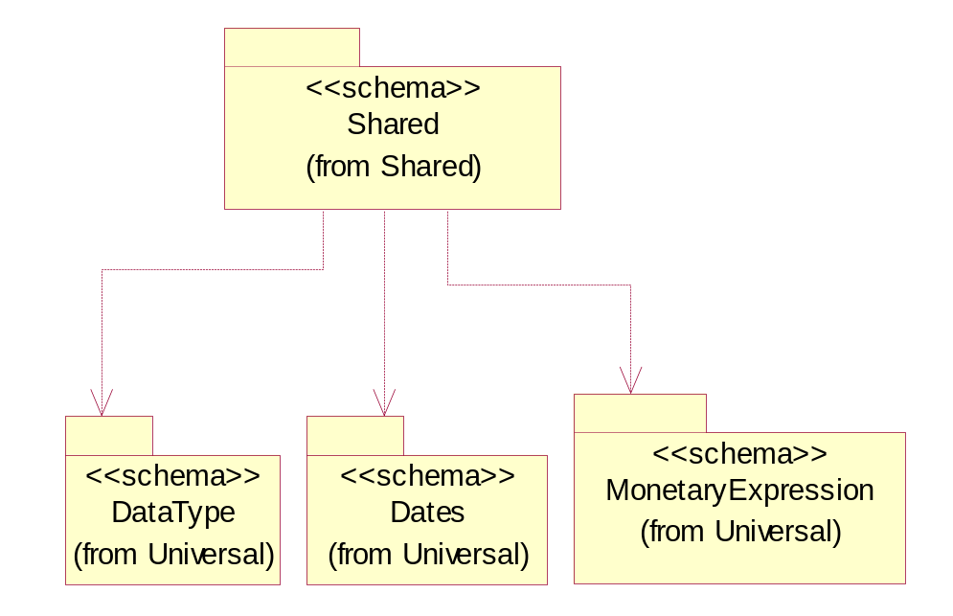
Figure ‎3-13 Dependency

CodeList

WarrantyType
The classification of each warranty coverage type that can be claimed.

Name | Documentation
CRI | Carry In - The warranty coverage for a unit that is carried in for repair.
DEP | Depot.
EVN | Event - The labor warranty coverage per incident.
FCL | Facilitation.
FLL | Full - A warranty which covers all aspects of the product.
LTD | Limited - A warranty which only certain aspects of the product which is described more fully in the warranty description.
OEM | OEM Service Pack.
ONS | Onsite - The warranty coverage for repairing a unit at the customer's location.
PCI | Portable Carry In - The warranty coverage for a portable unit that is carried in for repair.
PCK | Support Pack.
PLA | Parts and Labor - A warranty which covers both the parts cost as well as any labor charges required to replace those parts.
PRO | Parts Only - A warranty which covers only the parts cost of the product.
PRT | Part - The spare parts warranty coverage.
STD | Standard - Indicates standard warranty coverage.

Universal Structure

ContactInformation

ContactInformation
The business document must allow for the identification of the name of the department, service or individual to be contacted regarding the context of the business document.
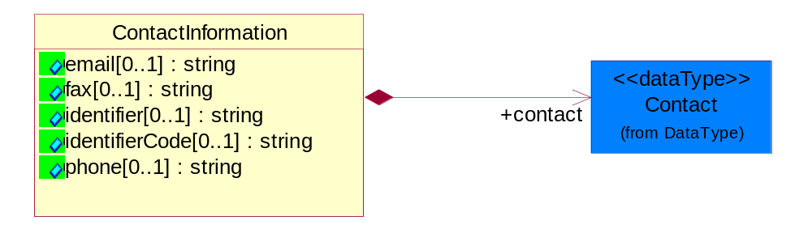
Figure ‎4-14 ContactInformation

Attribute | Type | Documentation
email[0..1] | string | The electronic mail for the specified contact.
fax[0..1] | string | The fax number for the specified contact.
identifier[0..1] | string | Identifies the role of the contact (i.e. Service Technician, Account Manager) in the Business Process.
identifierCode[0..1] | string | IdentifierCode is a unique security authorization code to identify the contact- ie. badge ID.
phone[0..1] | string | The telephone number for the specified contact.

Composition | Cardinality | Type | Documentation
contact | 1 | Contact | The name of the department, service or individual to be contacted within the organization.

DataType

Contact
The name of the department, service or individual to be contacted within the organization.
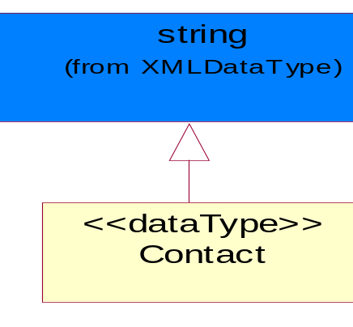
Figure ‎4-15 Contact

DUNS
A number assigned by Dun and Bradstreet to identify a business location.
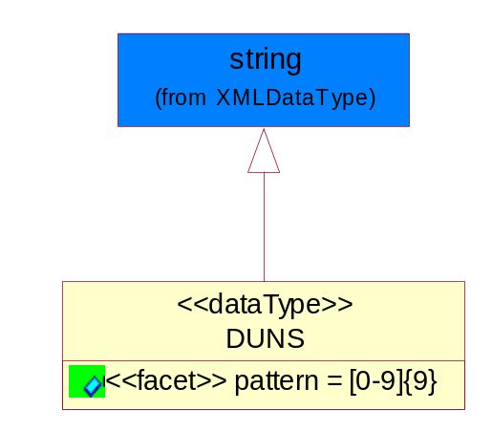
Figure ‎4-16 DUNS

Attribute | Type | Documentation
pattern |  | [0-9]{9}

DUNSPlus4
A identifier to specify a specific location within a business location.
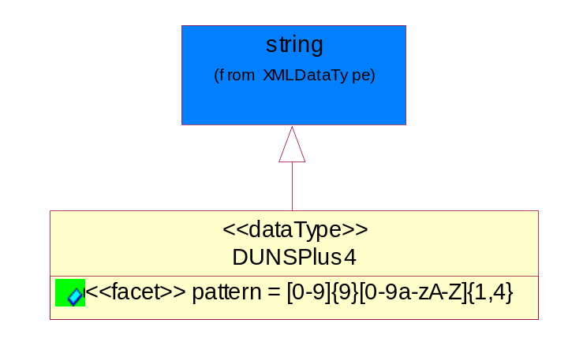
Figure ‎4-17 DUNSPlus4

Attribute | Type | Documentation
pattern |  | Data Universal Numbering System +4 (DUNS+4) number means the DUNS number assigned by Dun and Bradstreet, Inc. (D&B) plus an alphanumeric of length 4 suffix that may be assigned by a business concern.

GLN
Global Location Number (GLN) - A identifier to identify legal entities, trading parties and location.
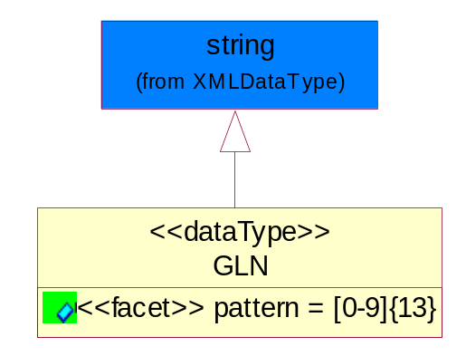
Figure ‎4-18 GLN

Attribute | Type | Documentation
pattern |  | [0-9]{13}

GTIN
Global Trade Identification Number (GTIN).
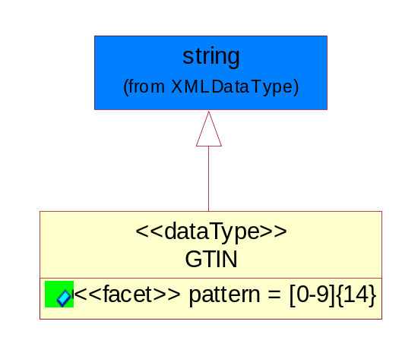
Figure ‎4-19 GTIN

Attribute | Type | Documentation
pattern |  | [0-9]{14}

Document

BusinessDocumentReference
The business document reference object allows for the indirect referencing of a relationship to other business related documents.
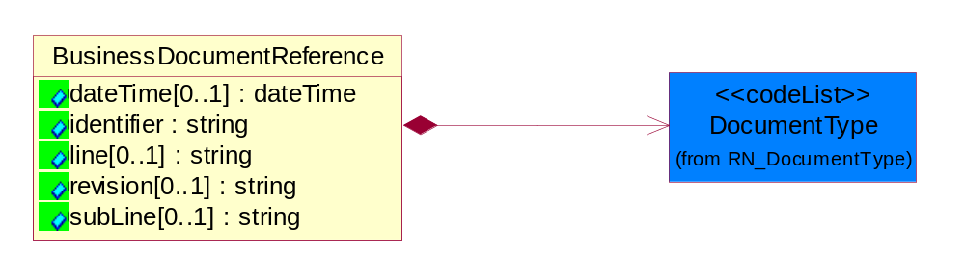
Figure ‎4-20 BusinessDocumentReference

Attribute | Type | Documentation
dateTime[0..1] | dateTime | The date-time stamp indicating on the referenced business document.
identifier | string | Unique identification of the referenced business document.
line[0..1] | string | References the specific line number of the specified business document.
revision[0..1] | string | Referenced the revision of the specified business document.
subLine[0..1] | string | References the specific subline number of the specified business document.

Composition | Cardinality | Type | Documentation
DocumentType | 1 | DocumentType | A code identifying the business context of a document.

Locations

AlternativeIdentifier
Identifies the specified code and the name of the organization that a code is utilized from.
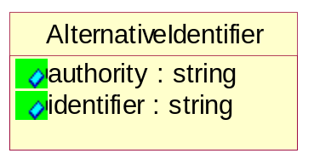
Figure ‎4-21 AlternativeIdentifier

Attribute | Type | Documentation
authority | string | The name of the organization that a code is utilized from.
identifier | string | The specified code to represent an entity (e.g. product, location, partner, etc.).

Location
The business document must specify a location.
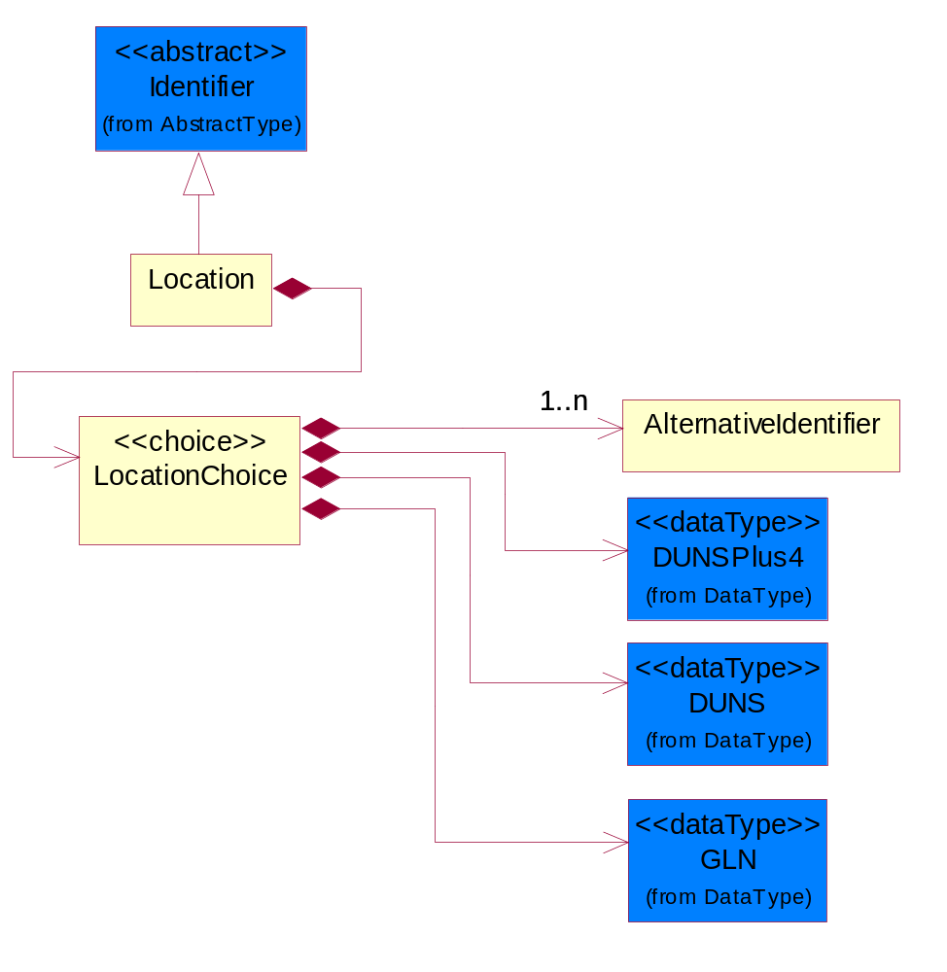
Figure ‎4-22 Location

Composition | Cardinality | Type | Documentation
LocationChoice | 1 | LocationChoice

LocationChoice

Composition | Cardinality | Type | Documentation
DUNSPlus4 | 1 | DUNSPlus4 | A identifier to specify a specific location within a business location.
DUNS | 1 | DUNS | A number assigned by Dun and Bradstreet to identify a business location.
AlternativeIdentifier | 1..n | AlternativeIdentifier | Identifies the specified code and the name of the organization that a code is utilized from.
GLN | 1 | GLN | Global Location Number (GLN) - A identifier to identify legal entities, trading parties and location.

PhysicalAddress
The business document must provide a physical address for a party to the business transaction.
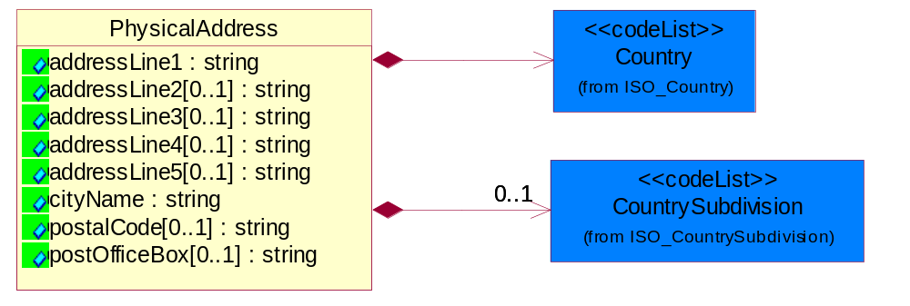
Figure ‎4-23 PhysicalAddress

Attribute | Type | Documentation
addressLine1 | string | The first line of a physical address.
addressLine2[0..1] | string | The second line of a physical address.
addressLine3[0..1] | string | The third line of a physical address.
addressLine4[0..1] | string | The fourth line of a physical address.
addressLine5[0..1] | string | The fifth line of a physical address.
cityName | string | The name of a city.
postalCode[0..1] | string | Identifying geographic location as specified by a national postal code.
postOfficeBox[0..1] | string | The Post Office Box identifier used to identify a party's post office box.

Composition | Cardinality | Type | Documentation
Country | 1 | Country | For representation of Country name RosettaNet has adopted ISO 3166-3; 1999. Refer to the following web page to get the latest version of the standard:  http://www.iso.ch/iso/en/prods-services/iso3166ma/02iso-3166-code-lists/index.html  If you need more information about the ISO standard please contact ISO for more details.
CountrySubdivision | 0..1 | CountrySubdivision | For representation of a Countries subdivisions RosettaNet has adopted ISO 3166-3; 1999. Refer to the following web page to get the latest version of the standard:  http://www.iso.ch/iso/en/prods-services/iso3166ma/02iso-3166-code-lists/index.html  If you need more information about the ISO standard please contact ISO for more details.

PartnerIdentification

PartnerIdentification
The business document must allow for the identity of one or more parties to the transaction.
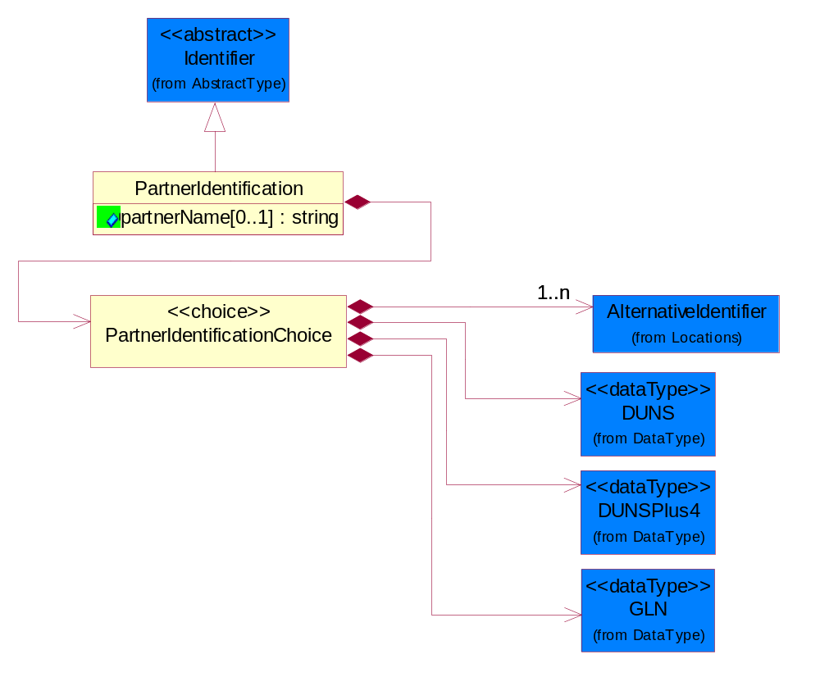
Figure ‎4-24 PartnerIdentification

Attribute | Type | Documentation
partnerName[0..1] | string | The name of the partner’s company/business.

Composition | Cardinality | Type | Documentation
PartnerIdentificationChoice | 1 | PartnerIdentificationChoice

PartnerIdentificationChoice

Composition | Cardinality | Type | Documentation
DUNS | 1 | DUNS | A number assigned by Dun and Bradstreet to identify a business location.
DUNSPlus4 | 1 | DUNSPlus4 | A identifier to specify a specific location within a business location.
AlternativeIdentifier | 1..n | AlternativeIdentifier | Identifies the specified code and the name of the organization that a code is utilized from.
GLN | 1 | GLN | Global Location Number (GLN) - A identifier to identify legal entities, trading parties and location.

SpecifiedFullPartner
The business document must describe the trading partners in the business transaction. This data structure provide the flexibility to describe a partner in all possible methods as for new, existing or known partner. This is specifically for partner who role has been specified.
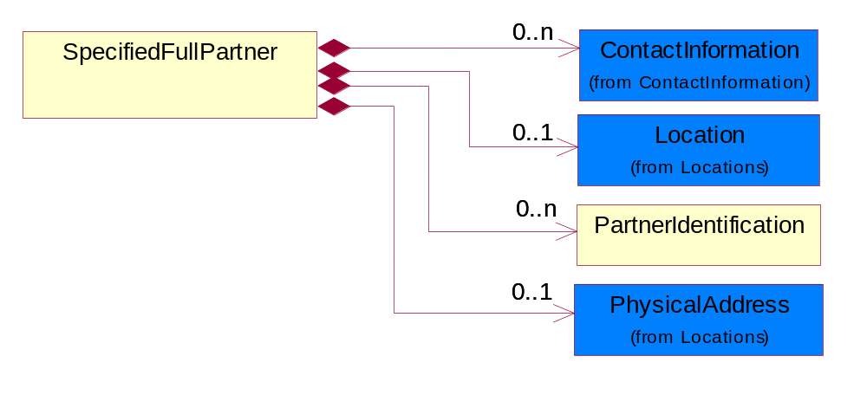
Figure ‎4-25 SpecifiedFullPartner

Composition | Cardinality | Type | Documentation
ContactInformation | 0..n | ContactInformation | The business document must allow for the identification of the name of the department, service or individual to be contacted regarding the context of the business document.
Location | 0..1 | Location | The business document must specify a location.
PartnerIdentification | 0..n | PartnerIdentification | The business document must allow for the identity of one or more parties to the transaction.
PhysicalAddress | 0..1 | PhysicalAddress | The business document must provide a physical address for a party to the business transaction.

SpecifiedIntermittentPartner
The business document must describe a physical address for a delivery.
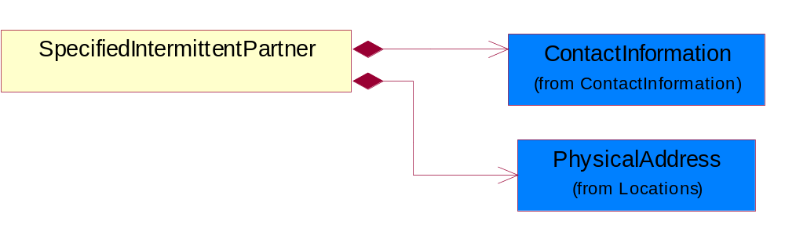
Figure ‎4-26 SpecifiedIntermittentPartner

Composition | Cardinality | Type | Documentation
ContactInformation | 1 | ContactInformation | The business document must allow for the identification of the name of the department, service or individual to be contacted regarding the context of the business document.
PhysicalAddress | 1 | PhysicalAddress | The business document must provide a physical address for a party to the business transaction.

SpecifiedKnownPartner
The business document must describe the trading partners in the business transaction.
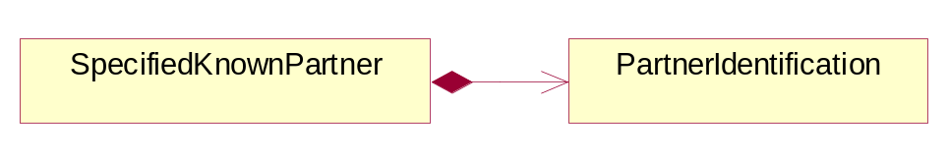
Figure ‎4-27 SpecifiedKnownPartner

Composition | Cardinality | Type | Documentation
PartnerIdentification | 1 | PartnerIdentification | The business document must allow for the identity of one or more parties to the transaction.

SpecifiedKnownPartnerContact
The business document must describe the trading partners in the business transaction and allow for a identification of an individual of the trading partner.
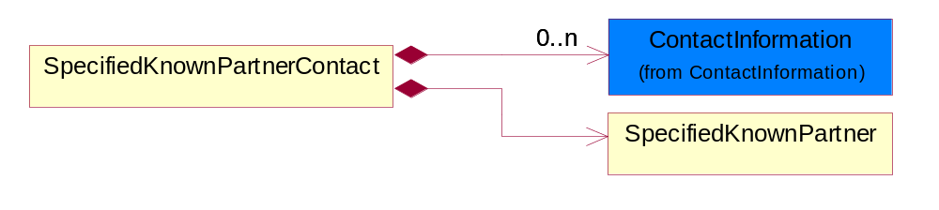
Figure ‎4-28 SpecifiedKnownPartnerContact

Composition | Cardinality | Type | Documentation
SpecifiedKnownPartner | 1 | SpecifiedKnownPartner | The business document must describe the trading partners in the business transaction.
ContactInformation | 0..n | ContactInformation | The business document must allow for the identification of the name of the department, service or individual to be contacted regarding the context of the business document.

SpecifiedNewPartner
The business document must describe a new, existing (but known to only one of the parties to the transaction) or an unknown party to the business transaction.
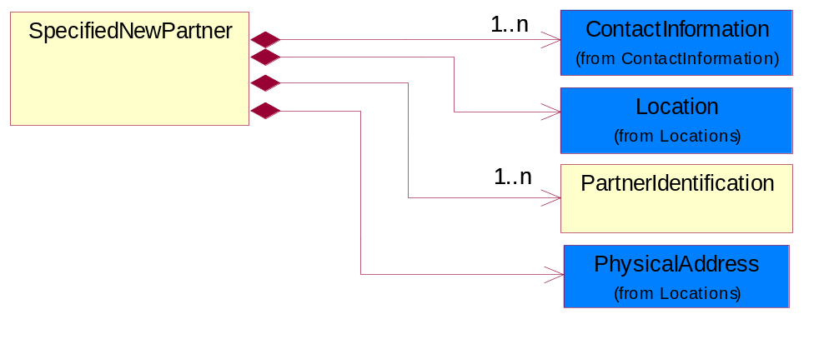
Figure ‎4-29 SpecifiedNewPartner

Composition | Cardinality | Type | Documentation
ContactInformation | 1..n | ContactInformation | The business document must allow for the identification of the name of the department, service or individual to be contacted regarding the context of the business document.
Location | 1 | Location | The business document must specify a location.
PhysicalAddress | 1 | PhysicalAddress | The business document must provide a physical address for a party to the business transaction.
PartnerIdentification | 1..n | PartnerIdentification | The business document must allow for the identity of one or more parties to the transaction.

SpecifiedPartnerDescription
The collection of business properties that describe a business partners' identity, their contact information, where they are physically located and their function in a supply chain.
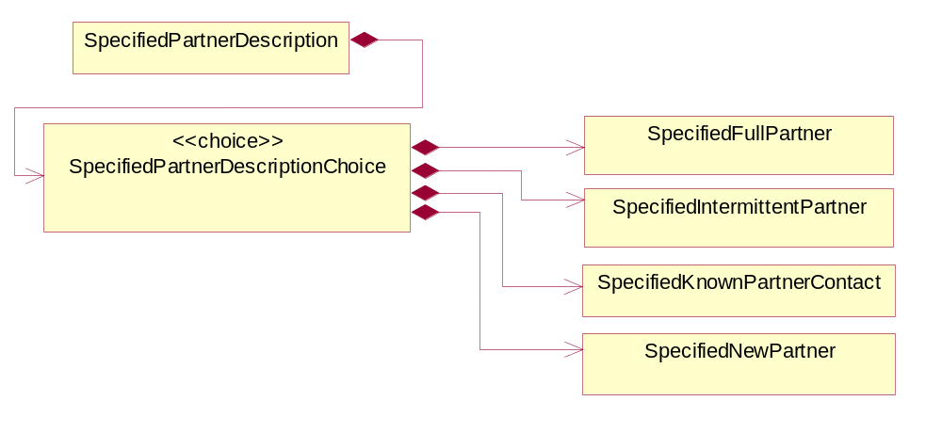
Figure ‎4-30 SpecifiedPartnerDescription

Composition | Cardinality | Type | Documentation
SpecifiedPartnerDescriptionChoice | 1 | SpecifiedPartnerDescriptionChoice

SpecifiedPartnerDescriptionChoice

Composition | Cardinality | Type | Documentation
SpecifiedKnownPartnerContact | 1 | SpecifiedKnownPartnerContact | The business document must describe the trading partners in the business transaction and allow for a identification of an individual of the trading partner.
SpecifiedIntermittentPartner | 1 | SpecifiedIntermittentPartner | The business document must describe a physical address for a delivery.
SpecifiedNewPartner | 1 | SpecifiedNewPartner | The business document must describe a new, existing (but known to only one of the parties to the transaction) or an unknown party to the business transaction.
SpecifiedFullPartner | 1 | SpecifiedFullPartner | The business document must describe the trading partners in the business transaction. This data structure provide the flexibility to describe a partner in all possible methods as for new, existing or known partner. This is specifically for partner who role has been specified.

ProductIdentification

ProductIdentification
The object provides the identifier(s) of a product.
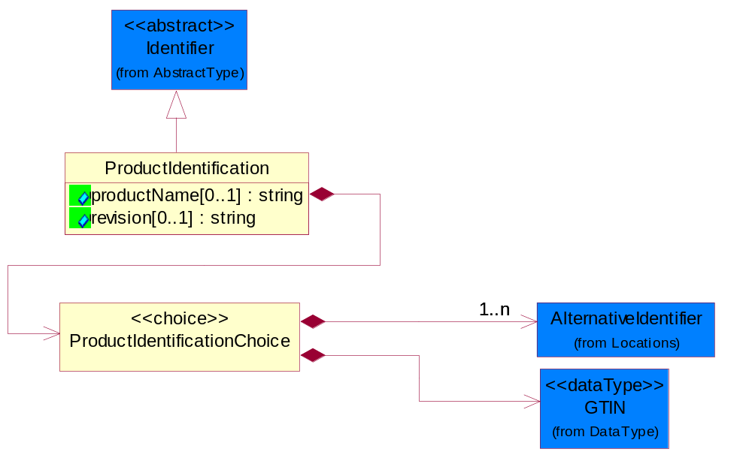
Figure ‎4-31 ProductIdentification

Attribute | Type | Documentation
productName[0..1] | string | The name of the product.
revision[0..1] | string | Referenced the specified product revision.

Composition | Cardinality | Type | Documentation
ProductIdentificationChoice | 1 | ProductIdentificationChoice

ProductIdentificationChoice

Composition | Cardinality | Type | Documentation
AlternativeIdentifier | 1..n | AlternativeIdentifier | Identifies the specified code and the name of the organization that a code is utilized from.
GTIN | 1 | GTIN | Global Trade Identification Number (GTIN).

ProductSerialIdentification
The object provides the serial identifier of a product.
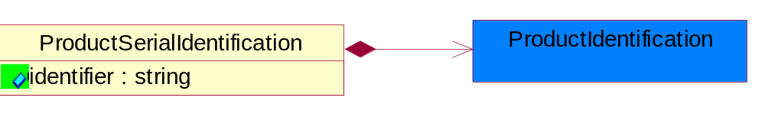
Figure ‎4-32 ProductSerialIdentification

Attribute | Type | Documentation
identifier | string | A unique serial identifier assigned to a product.

Composition | Cardinality | Type | Documentation
ProductIdentification | 1 | ProductIdentification | The object provides the identifier(s) of a product.

CodeList

Country
For representation of Country name RosettaNet has adopted ISO 3166-3; 1999. Refer to the following web page to get the latest version of the standard:
http://www.iso.ch/iso/en/prods-services/iso3166ma/02iso-3166-code-lists/index.html

If you need more information about the ISO standard please contact ISO for more details.

CountrySubdivision
For representation of a Countries subdivisions RosettaNet has adopted ISO 3166-3; 1999. Refer to the following web page to get the latest version of the standard:
http://www.iso.ch/iso/en/prods-services/iso3166ma/02iso-3166-code-lists/index.html

If you need more information about the ISO standard please contact ISO for more details.

Language
For representation of Language name RosettaNet has adopted ISO 639-2; 1998. Refer to the following web page to get the latest version of the standard:

http://www.loc.gov/standards/iso639-2/iso639jac.html

If you need more information about the ISO standard please contact ISO for more details.

DocumentType
A code identifying the business context of a document.

Instance | Documentation
APM | Applied Promotions.
ARA | Authorization Request Approval.
CAR | Certificate of Analysis Response.
CBN | Product batch number of customer.
CCN | Customs clearance number.
CFA | Failure Analysis - Request document that will accompany the product providing characteristics of the component failure.
CIN | Commercial Invoice.
CNM | Traditional credit note or memo.
COA | Certificate of Analysis.
CON | In a virtual sourcing relationship, a third party trading partner is supplying a part to a customer on behalf of another company that has taken the order for the customer. In this case a Customer Order Number is associated to the request for material that is sent to the virtual trading partners.
COS | Consumption Notice.
COT | Contract.
CRN | Unique consumption reference number identifying the product consumption issue i.e. one-to-one relationship with physical flow.
DEM | Traditional debit note or memo.
DEN | Delivery Note.
DIN | Discontinuation Notice.
DOR | Delivery Order.
DRN | Drawing Number.
DRR | Design Registration Request.
ECO | Engineering Change Order - The proprietary unique identification number that represents an engineering change order.
EDD | Export Declaration Document.
EIR | Engineering Information Request.
EOL | End of Life.
FUO | Sales order or transfer order fulfilling demand out of a facility (outbound shipment).
IDD | Import Declaration Document.
INV | Invoice.
LID | Location Identifier. Data for on-site work that have to be done on the machine (associated with preventive maintenance order).
MEN | Master Event Number.
MID | Machine Identifier. Data for on-site work that have to be done on the machine (associated with preventive maintenance order).
MON | Model Number.
NTS | Notes.
OCL | The unique identifier assigned by the OEM for a warranty claim.
OGA | Other governmental agency issued document.
OPO | The unique identifier assigned by the OEM for a part order.
OPR | The unique identifier assigned by the OEM for a part return.
PCN | Product/Process Change.
PFA | Failure Analysis - Request document that will accompany the product providing characteristics of the product failure.
PII | Refers to previously issued invoice.
PLS | Unique number that identifies packing form prior to shipment.
POI | Purchase Order IN.
PON | Production order number for material release.
POO | Purchase Order OUT.
PRC | Product Catalog.
PSI | Refers to previously issued self-billing invoice.
PUO | Purchase Order.
QUO | Quote.
REC | Document identifying the receipt of materials or products into a facility against a purchase order or transfer order (inbound shipment).
REN | Release Number.
REO | Purchase order or transfer order replenishing inventory into a facility (inbound shipment).
REQ | Requisition.
RMA | Returned Material Authorization.
RPO | Purchase order for materials or product returned to and reworked by a supplier.
RTA | Remittance Advice - Remittance details.
SAO | Sales Order.
SBC | Credit Memo used in self-billing scenario.
SBD | Debit Memo used in self-billing scenario.
SBI | Invoice in self billing scenario.
SBN | Product batch number of supplier.
SCA | Similar to contracts - Contains the quantity of an article that is to be ordered from a vendor and the price for article or service that is to be procured.
SEN | Serial Number.
SEO | A document that gives a repair provider the necessary authorization to repair or upgrade a product either at the customer site or at the repair provider’s site.
SHD | Shipping Document.
SNC | Shipset Number on Code List.
SPC | The unique identifier assigned by the ASP for a warranty claim.
SPN | Spec Number.
SPO | The unique identifier assigned by the ASP for a part order.
SPR | The unique identifier assigned by the ASP for a part return.
SPW | The unique identifier assigned by the ASP to reference a work order.
SRI | A document that contains the shipping reference number which allows the product to be tracked within the outsourced logistic providers network.
SWT | Switch Authorization.
TCS | Terms and Conditions.
TRO | Order which results in materials or products being moved from one facility to another (outbound shipment and inbound shipment).
WAB | Waybill.
WAC | Denotes a warranty claim.
WOO | Work Order.

MimeTypeQualifier
The MIME type as defined by IANA.

Please refer to http://www.iana.org/assignments/media-types/ for a list of types.

Instance | Documentation
application/activemessage | [Shapiro]
application/andrew-inset | [Borenstein]
application/applefile | [Faltstrom]
application/atomicmail | [Borenstein]
application/batch-SMTP | [RFC2442]
application/beep+xml | [RFC3080]
application/cals-1840 | [RFC1895]
application/cnrp+xml | [RFCCNRP]
application/commonground | [Glazer]
application/cpl+xml
application/cybercash | [Eastlake]
application/dca-rft | [Campbell]
application/dec-dx | [Campbell]
application/dicom | [RFC3240]
application/dvcs | [RFC3029]
application/EDI-Consent | [RFC1767]
application/EDIFACT | [RFC1767]
application/EDI-X12 | [RFC1767]
application/eshop | [Katz]
application/font-tdpfr | [RFC3073]
application/http | [RFC2616]
application/hyperstudio | [Domino]
application/iges | [Parks]
application/index | [RFC2652]
application/index.cmd | [RFC2652]
application/index.obj | [RFC2652]
application/index.response | [RFC2652]
application/index.vnd | [RFC2652]
application/iotp | [RFC2935]
application/ipp | [RFC2910]
application/isup | [RFC3204]
application/mac-binhex40 | [Faltstrom]
application/macwriteii | [Lindner]
application/marc | [RFC2220]
application/mathematica | [Van Nostern]
application/msword | [Lindner]
application/news-message-id | [RFC1036,Spencer]
application/news-transmission | [RFC1036, Spencer]
application/ocsp-request | [RFC2560]
application/ocsp-response | [RFC2560]
application/octet-stream | [RFC2045,RFC2046]
application/oda | [RFC2045,RFC2046]
application/ogg | [RFC-walleij-ogg-mediatype-08.txt]
application/parityfec | [RFC3009]
application/pdf | [Lindner]
application/pgp-encrypted | [RFC3156]
application/pgp-keys | [RFC3156]
application/pgp-signature | [RFC3156]
application/pkcs10 | [RFC2311]
application/pkcs7-mime | [RFC2311]
application/pkcs7-signature | [RFC2311]
application/pkix-cert | [RFC2585]
application/pkixcmp | [RFC2510]
application/pkix-crl | [RFC2585]
application/postscript | [RFC2045,RFC2046]
application/prs.alvestrand.titrax-sheet | [Alvestrand]
application/prs.cww | [Rungchavalnont]
application/prs.nprend | [Doggett]
application/prs.plucker | [Janssen]
application/qsig | [RFC3204]
application/reginfo+xml | [RFC-ietf-sipping-reg-event-00.txt]
application/remote-printing | [RFC1486,Rose]
application/riscos | [Smith]
application/rtf | [Lindner]
application/sdp | [RFC2327]
application/set-payment | [Korver]
application/set-payment-initiation | [Korver]
application/set-registration | [Korver]
application/set-registration-initiation | [Korver]
application/sgml | [RFC1874]
application/sgml-open-catalog | [Grosso]
application/sieve | [RFC3028]
application/slate | [Crowley]
application/timestamp-query | [RFC3161]
application/timestamp-reply | [RFC3161]
application/tve-trigger | [Welsh]
application/vemmi | [RFC2122]
application/vnd.3gpp.pic-bw-large | [Meredith]
application/vnd.3gpp.pic-bw-small | [Meredith]
application/vnd.3gpp.pic-bw-var | [Meredith]
application/vnd.3gpp.sms | [Meredith]
application/vnd.3M.Post-it-Notes | [O'Brien]
application/vnd.accpac.simply.aso | [Leow]
application/vnd.accpac.simply.imp | [Leow]
application/vnd.acucobol | [Lubin]
application/vnd.acucorp | [Lubin]
application/vnd.adobe.xfdf | [Perelman]
application/vnd.aether.imp | [Moskowitz]
application/vnd.amiga.ami | [Blumberg]
application/vnd.anser-web-certificate-issue-initiation | [Mori]
application/vnd.anser-web-funds-transfer-initiation | [Mori]
application/vnd.audiograph | [Slusanschi]
application/vnd.blueice.multipass | [Holmstrom]
application/vnd.bmi | [Gotoh]
application/vnd.businessobjects | [Imoucha]
application/vnd.canon-cpdl | [Muto]
application/vnd.canon-lips | [Muto]
application/vnd.cinderella | [Kortenkamp]
application/vnd.claymore | [Simpson]
application/vnd.commerce-battelle | [Applebaum]
application/vnd.commonspace | [Chandhok]
application/vnd.contact.cmsg | [Patz]
application/vnd.cosmocaller | [Dellutri]
application/vnd.ctc-posml | [Kohlhepp]
application/vnd.cups-postscript | [Sweet]
application/vnd.cups-raster | [Sweet]
application/vnd.cups-raw | [Sweet]
application/vnd.curl | [Byrnes]
application/vnd.cybank | [Helmee]
application/vnd.data-vision.rdz | [Fields]
application/vnd.dna | [Searcy]
application/vnd.dpgraph | [Parker]
application/vnd.dreamfactory | [Appleton]
application/vnd.dxr | [Duffy]
application/vnd.ecdis-update | [Buettgenbach]
application/vnd.ecowin.chart | [Olsson]
application/vnd.ecowin.filerequest | [Olsson]
application/vnd.ecowin.fileupdate | [Olsson]
application/vnd.ecowin.series | [Olsson]
application/vnd.ecowin.seriesrequest | [Olsson]
application/vnd.ecowin.seriesupdate | [Olsson]
application/vnd.enliven | [Santinelli]
application/vnd.epson.esf | [Hoshina]
application/vnd.epson.msf | [Hoshina]
application/vnd.epson.quickanime | [Gu]
application/vnd.epson.salt | [Nagatomo]
application/vnd.epson.ssf | [Hoshina]
application/vnd.ericsson.quickcall | [Tidwell]
application/vnd.eudora.data | [Resnick]
application/vnd.fdf | [Zilles]
application/vnd.ffsns | [Holstage]
application/vnd.FloGraphIt | [Floersch]
application/vnd.framemaker | [Wexler]
application/vnd.fsc.weblaunch | [D.Smith]
application/vnd.fujitsu.oasys | [Togashi]
application/vnd.fujitsu.oasys2 | [Togashi]
application/vnd.fujitsu.oasys3 | [Okudaira]
application/vnd.fujitsu.oasysgp | [Sugimoto]
application/vnd.fujitsu.oasysprs | [Ogita]
application/vnd.fujixerox.ddd | [Onda]
application/vnd.fujixerox.docuworks | [Taguchi]
application/vnd.fujixerox.docuworks.binder | [Matsumoto]
application/vnd.fut-misnet | [Pruulmann]
application/vnd.grafeq | [Tupper]
application/vnd.groove-account | [Joseph]
application/vnd.groove-help | [Joseph]
application/vnd.groove-identity-message | [Joseph]
application/vnd.groove-injector | [Joseph]
application/vnd.groove-tool-message | [Joseph]
application/vnd.groove-tool-template | [Joseph]
application/vnd.groove-vcard | [Joseph]
application/vnd.hbci | [Hammann]
application/vnd.hhe.lesson-player | [Jones]
application/vnd.hp-HPGL | [Pentecost]
application/vnd.hp-hpid | [Gupta]
application/vnd.hp-hps | [Aubrey]
application/vnd.hp-PCL | [Pentecost]
application/vnd.hp-PCLXL | [Pentecost]
application/vnd.httphone | [Lefevre]
application/vnd.hzn-3d-crossword | [Minnis]
application/vnd.ibm.afplinedata | [Buis]
application/vnd.ibm.electronic-media | [Tantlinger]
application/vnd.ibm.MiniPay | [Herzberg]
application/vnd.ibm.modcap | [Hohensee]
application/vnd.ibm.secure-container | [Tantlinger]
application/vnd.informix-visionary | [Gales]
application/vnd.intercon.formnet | [Gurak]
application/vnd.intertrust.digibox | [Tomasello]
application/vnd.intertrust.nncp | [Tomasello]
application/vnd.intu.qbo | [Scratchley]
application/vnd.intu.qfx | [Scratchley]
application/vnd.irepository.package+xml | [Knowles]
application/vnd.is-xpr | [Natarajan]
application/vnd.japannet-directory-service | [Fujii]
application/vnd.japannet-jpnstore-wakeup | [Yoshitake]
application/vnd.japannet-payment-wakeup | [Fujii]
application/vnd.japannet-registration | [Yoshitake]
application/vnd.japannet-registration-wakeup | [Fujii]
application/vnd.japannet-setstore-wakeup | [Yoshitake]
application/vnd.japannet-verification | [Yoshitake]
application/vnd.japannet-verification-wakeup | [Fujii]
application/vnd.jisp | [Deckers]
application/vnd.kde.karbon | [Faure]
application/vnd.kde.kchart | [Faure]
application/vnd.kde.kformula | [Faure]
application/vnd.kde.kivio | [Faure]
application/vnd.kde.kontour | [Faure]
application/vnd.kde.kpresenter | [Faure]
application/vnd.kde.kspread | [Faure]
application/vnd.kde.kword | [Faure]
application/vnd.kenameaapp | [DiGiorgio-Haag]
application/vnd.koan | [Cole]
application/vnd.liberty-request+xml | [McDowell]
application/vnd.llamagraphics.life-balance.desktop | [White]
application/vnd.lotus-1-2-3 | [Wattenberger]
application/vnd.lotus-approach | [Wattenberger]
application/vnd.lotus-freelance | [Wattenberger]
application/vnd.lotus-notes | [Laramie]
application/vnd.lotus-organizer | [Wattenberger]
application/vnd.lotus-screencam | [Wattenberger]
application/vnd.lotus-wordpro | [Wattenberger]
application/vnd.mcd | [Gotoh]
application/vnd.mediastation.cdkey | [Flurry]
application/vnd.meridian-slingshot | [Wedel]
application/vnd.micrografx.flo | [Prevo]
application/vnd.micrografx.igx | [Prevo]
application/vnd.mif | [Wexler]
application/vnd.minisoft-hp3000-save | [Bartram]
application/vnd.mitsubishi.misty-guard.trustweb | [Tanaka]
application/vnd.Mobius.DAF | [Kabayama]
application/vnd.Mobius.DIS | [Kabayama]
application/vnd.Mobius.MBK | [Devasia]
application/vnd.Mobius.MQY | [Devasia]
application/vnd.Mobius.MSL | [Kabayama]
application/vnd.Mobius.PLC | [Kabayama]
application/vnd.Mobius.TXF | [Kabayama]
application/vnd.mophun.application | [Wennerstrom]
application/vnd.mophun.certificate | [Wennerstrom]
application/vnd.motorola.flexsuite | [Patton]
application/vnd.motorola.flexsuite.adsi | [Patton]
application/vnd.motorola.flexsuite.fis | [Patton]
application/vnd.motorola.flexsuite.gotap | [Patton]
application/vnd.motorola.flexsuite.kmr | [Patton]
application/vnd.motorola.flexsuite.ttc | [Patton]
application/vnd.motorola.flexsuite.wem | [Patton]
application/vnd.mozilla.xul+xml | [McDaniel]
application/vnd.ms-artgalry | [Slawson]
application/vnd.ms-asf | [Fleischman]
application/vnd.mseq | [Le Bodic]
application/vnd.ms-excel | [Gill]
application/vnd.msign | [Borcherding]
application/vnd.ms-lrm | [Ledoux]
application/vnd.ms-powerpoint | [Gill]
application/vnd.ms-project | [Gill]
application/vnd.ms-tnef | [Gill]
application/vnd.ms-works | [Gill]
application/vnd.ms-wpl | [Plastina]
application/vnd.musician | [Adams]
application/vnd.music-niff | [Butler]
application/vnd.netfpx | [Mutz]
application/vnd.noblenet-directory | [Solomon]
application/vnd.noblenet-sealer | [Solomon]
application/vnd.noblenet-web | [Solomon]
application/vnd.novadigm.EDM | [Swenson]
application/vnd.novadigm.EDX | [Swenson]
application/vnd.novadigm.EXT | [Swenson]
application/vnd.obn | [Hessling]
application/vnd.osa.netdeploy | [Klos]
application/vnd.palm | [Peacock]
application/vnd.pg.format | [Gandert]
application/vnd.pg.osasli | [Gandert]
application/vnd.powerbuilder6 | [Guy]
application/vnd.powerbuilder6-s | [Guy]
application/vnd.powerbuilder7 | [Shilts]
application/vnd.powerbuilder75 | [Shilts]
application/vnd.powerbuilder75-s | [Shilts]
application/vnd.powerbuilder7-s | [Shilts]
application/vnd.previewsystems.box | [Smolgovsky]
application/vnd.publishare-delta-tree | [Ben-Kiki]
application/vnd.pvi.ptid1 | [Lamb]
application/vnd.pwg-multiplexed | [RFC3391]
application/vnd.pwg-xhtml-print+xml | [Wright]
application/vnd.Quark.QuarkXPress | [Scheidler]
application/vnd.rapid | [Szekely]
application/vnd.s3sms | [Tarkkala]
application/vnd.sealed.net | [Lambert]
application/vnd.seemail | [Webb]
application/vnd.shana.informed.formdata | [Selzler]
application/vnd.shana.informed.formtemplate | [Selzler]
application/vnd.shana.informed.interchange | [Selzler]
application/vnd.shana.informed.package | [Selzler]
application/vnd.smaf | [Takahashi]
application/vnd.sss-cod | [Dani]
application/vnd.sss-dtf | [Bruno]
application/vnd.sss-ntf | [Bruno]
application/vnd.street-stream | [Levitt]
application/vnd.svd | [Becker]
application/vnd.swiftview-ics | [Widener]
application/vnd.triscape.mxs | [Simonoff]
application/vnd.trueapp | [Hepler]
application/vnd.truedoc | [Chase]
application/vnd.ufdl | [Manning]
application/vnd.uplanet.alert | [Martin]
application/vnd.uplanet.alert-wbxml | [Martin]
application/vnd.uplanet.bearer-choice | [Martin]
application/vnd.uplanet.bearer-choice-wbxml | [Martin]
application/vnd.uplanet.cacheop | [Martin]
application/vnd.uplanet.cacheop-wbxml | [Martin]
application/vnd.uplanet.channel | [Martin]
application/vnd.uplanet.channel-wbxml | [Martin]
application/vnd.uplanet.list | [Martin]
application/vnd.uplanet.listcmd | [Martin]
application/vnd.uplanet.listcmd-wbxml | [Martin]
application/vnd.uplanet.list-wbxml | [Martin]
application/vnd.uplanet.signal | [Martin]
application/vnd.vcx | [T.Sugimoto]
application/vnd.vectorworks | [Pharr]
application/vnd.vidsoft.vidconference | [Hess]
application/vnd.visio | [Sandal]
application/vnd.visionary | [Aravindakumar]
application/vnd.vividence.scriptfile | [Risher]
application/vnd.vsf | [Rowe]
application/vnd.wap.sic | [WAP-Forum]
application/vnd.wap.slc | [WAP-Forum]
application/vnd.wap.wbxml | [Stark]
application/vnd.wap.wmlc | [Stark]
application/vnd.wap.wmlscriptc | [Stark]
application/vnd.webturbo | [Rehem]
application/vnd.wrq-hp3000-labelled | [Bartram]
application/vnd.wt.stf | [Wohler]
application/vnd.wv.csp+wbxml | [Salmi]
application/vnd.xara | [Matthewman]
application/vnd.xfdl | [Manning]
application/vnd.yellowriver-custom-menu | [Yellow]
application/whoispp-query | [RFC2957]
application/whoispp-response | [RFC2958]
application/wita | [Campbell]
application/wordperfect5.1 | [Lindner]
application/x400-bp | [RFC1494]
application/xhtml+xml | [RFC3236]
application/xml | [RFC3023]
application/xml-dtd | [RFC3023]
application/xml-external-parsed-entity | [RFC3023]
application/zip | [Lindner]
audio/32kadpcm | [RFC2421,RFC2422]
audio/AMR | [RFC3267]
audio/AMR-WB | [RFC3267]
audio/basic | [RFC2045,RFC2046]
audio/CN | [RFC3389]
audio/DAT12 | [RFC3190]
audio/DVI4
audio/EVRC | [RFC-ietf-avt-evrc-smv-03.txt]
audio/EVRC0 | [RFC-ietf-avt-evrc-smv-03.txt]
audio/G.722.1 | [RFC3047]
audio/G722
audio/G723
audio/G726-16
audio/G726-24
audio/G726-32
audio/G726-40
audio/G728
audio/G729
audio/G729D
audio/G729E
audio/GSM
audio/GSM-EFR
audio/L16 | [RFC2586]
audio/L20 | [RFC3190]
audio/L24 | [RFC3190]
audio/L8
audio/LPC
audio/MP4A-LATM | [RFC3016]
audio/MPA
audio/mpa-robust | [RFC3119]
audio/mpeg | [RFC3003]
audio/parityfec | [RFC3009]
audio/PCMA
audio/PCMU
audio/prs.sid | [Walleij]
audio/QCELP
audio/RED
audio/SMV | [RFC-ietf-avt-evrc-smv-03.txt]
audio/SMV0 | [RFC-ietf-avt-evrc-smv-03.txt]
audio/telephone-event | [RFC2833]
audio/tone | [RFC2833]
audio/VDVI
audio/vnd.3gpp.iufp | [Belling]
audio/vnd.cisco.nse | [Kumar]
audio/vnd.cns.anp1 | [McLaughlin]
audio/vnd.cns.inf1 | [McLaughlin]
audio/vnd.digital-winds | [Strazds]
audio/vnd.everad.plj | [Cicelsky]
audio/vnd.lucent.voice | [Vaudreuil]
audio/vnd.nortel.vbk | [Parsons]
audio/vnd.nuera.ecelp4800 | [Fox]
audio/vnd.nuera.ecelp7470 | [Fox]
audio/vnd.nuera.ecelp9600 | [Fox]
audio/vnd.octel.sbc | [Vaudreuil]
audio/vnd.qcelp | [Lundblade]
audio/vnd.rhetorex.32kadpcm | [Vaudreuil]
audio/vnd.vmx.cvsd | [Vaudreuil]
image/cgm | Computer Graphics Metafile
image/g3fax | [RFC1494]
image/gif | [RFC2045,RFC2046]
image/ief | [RFC1314] Image Exchange Format
image/jpeg | [RFC2045,RFC2046]
image/naplps | [Ferber]
image/png | [Randers-Pehrson]
image/prs.btif | [Simon]
image/prs.pti | [Laun]
image/t38 | [RFC3362]
image/tiff | [RFC3302] Tag Image File Format
image/tiff-fx | [RFC3250] Tag Image File Format Fax eXtended
image/vnd.cns.inf2 | [McLaughlin]
image/vnd.djvu | [Bottou]
image/vnd.dwg | [Moline]
image/vnd.dxf | [Moline]
image/vnd.fastbidsheet | [Becker]
image/vnd.fpx | [Spencer]
image/vnd.fst | [Fuldseth]
image/vnd.fujixerox.edmics-mmr | [Onda]
image/vnd.fujixerox.edmics-rlc | [Onda]
image/vnd.globalgraphics.pgb | [Bailey]
image/vnd.mix | [Reddy]
image/vnd.ms-modi | [Vaughan]
image/vnd.net-fpx | [Spencer]
image/vnd.svf | [Moline]
image/vnd.wap.wbmp | [Stark]
image/vnd.xiff | [S.Martin]
message/delivery-status | [RFC1894]
message/disposition-notification | [RFC2298]
message/external-body | [RFC2045,RFC2046]
message/http | [RFC2616]
message/news | [RFC 1036, H.Spencer]
message/partial | [RFC2045,RFC2046]
message/rfc822 | [RFC2045,RFC2046]
message/s-http | [RFC2660]
message/sip | [RFC3261]
message/sipfrag | [RFC3420]
model/iges | [Parks]
model/mesh | [RFC2077]
model/vnd.dwf | [Pratt]
model/vnd.flatland.3dml | [Powers]
model/vnd.gdl | [Babits]
model/vnd.gs-gdl | [Babits]
model/vnd.gtw | [Ozaki]
model/vnd.mts | [Rabinovitch]
model/vnd.parasolid.transmit.binary | [Parasolid]
model/vnd.parasolid.transmit.text | [Parasolid]
model/vnd.vtu | [Rabinovitch]
model/vrml | [RFC2077]
multipart/alternative | [RFC2045,RFC2046]
multipart/appledouble | [Faltstrom]
multipart/byteranges | [RFC2068]
multipart/digest | [RFC2045,RFC2046]
multipart/encrypted | [RFC1847]
multipart/form-data | [RFC2388]
multipart/header-set | [Crocker]
multipart/mixed | [RFC2045,RFC2046]
multipart/parallel | [RFC2045,RFC2046]
multipart/related | [RFC2387]
multipart/report | [RFC1892]
multipart/signed | [RFC1847]
multipart/voice-message | [RFC2421,RFC2423]
text/calendar | [RFC2445]
text/css | [RFC2318]
text/directory | [RFC2425]
text/enriched | [RFC1896]
text/html | [RFC2854]
text/parityfec | [RFC3009]
text/plain | [RFC2646,RFC2046]
text/prs.lines.tag | [Lines]
text/rfc822-headers | [RFC1892]
text/richtext | [RFC2045,RFC2046]
text/rtf | [Lindner]
text/sgml | [RFC1874]
text/t140 | [RFC2793]
text/tab-separated-values | [Lindner]
text/uri-list | [RFC2483]
text/vnd.abc | [Allen]
text/vnd.curl | [Byrnes]
text/vnd.DMClientScript | [Bradley]
text/vnd.fly | [Gurney]
text/vnd.fmi.flexstor | [Hurtta]
text/vnd.in3d.3dml | [Powers]
text/vnd.in3d.spot | [Powers]
text/vnd.IPTC.NewsML | [IPTC]
text/vnd.IPTC.NITF | [IPTC]
text/vnd.latex-z | [Lubos]
text/vnd.motorola.reflex | [Patton]
text/vnd.ms-mediapackage | [Nelson]
text/vnd.net2phone.commcenter.command | [Xie]
text/vnd.sun.j2me.app-descriptor | [G.Adams]
text/vnd.wap.si | [WAP-Forum]
text/vnd.wap.sl | [WAP-Forum]
text/vnd.wap.wml | [Stark]
text/vnd.wap.wmlscript | [Stark]
text/xml | [RFC3023]
text/xml-external-parsed-entity | [RFC3023]
video/BMPEG
video/BT656
video/CelB
video/DV | [RFC3189]
video/H261
video/H263
video/H263-1998
video/H263-2000
video/JPEG
video/MP1S
video/MP2P
video/MP2T
video/MP4V-ES | [RFC3016]
video/mpeg | [RFC2045,RFC2046]
video/MPV
video/nv
video/parityfec | [RFC3009]
video/pointer | [RFC2862]
video/quicktime | [Lindner]
video/SMPTE292M | [RFC-avt-smpte292-video-08.txt]
video/vnd.fvt | [Fuldseth]
video/vnd.motorola.video | [McGinty]
video/vnd.motorola.videop | [McGinty]
video/vnd.mpegurl | [Recktenwald]
video/vnd.nokia.interleaved-multimedia | [Kangaslampi]
video/vnd.objectvideo | [Clark]
video/vnd.vivo | [Wolfe]

System Structure

BusinessProcessIdentifier
A Business Process Identifier to uniquely define the TPIR-PIP 'role' within a Business Scenario at a company or MNC level. The identifier MUST be composed of alphanumeric characters only and its length MUST be between one and twelve characters.
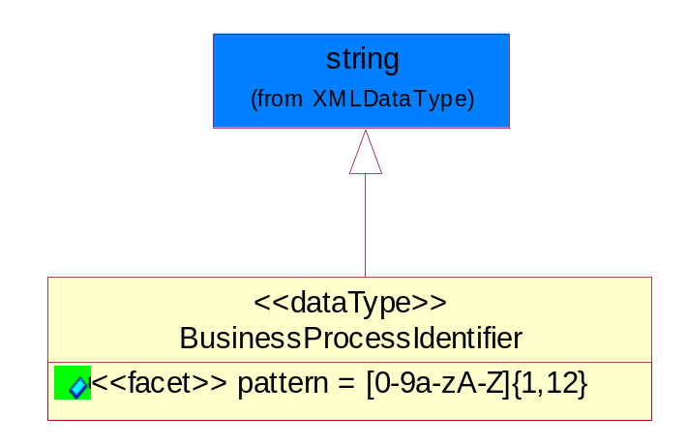
Figure ‎5-33 BusinessProcessIdentifier

Attribute | Type | Documentation
pattern |  | [0-9a-zA-Z]{1,12}

BusinessServiceInformation
The object allows the specification of the business service utilized within the partner company. This may or may not be the same as the information sent by the RNIF.
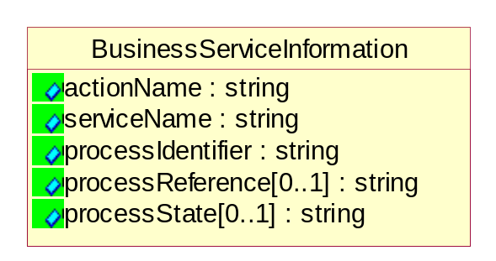
Figure ‎5-34 BusinessServiceInformation

Attribute | Type | Documentation
actionName | string | The name of Action. For RosettaNet usually any of Request/Confirm/Notify/Query/Response.
serviceName | string | The name of the Business Activity with the "Request/Confirm" part removed. E.g., for the Activity "Request Purchase Order"==> "Purchase Order".
processIdentifier | string | The name of the PIP e.g. Notify of Forecast Reply.
processReference[0..1] | string | The URN for the PIP that includes Cluster/Segment/Process pattern used to identify the interface process (such as PIP3A4)
processState[0..1] | string | The business process (or service) state of the sender of a document. When a service receives this document, the receiver may use the state as a precondition.

ContractInformation
A block of information used to correlate a contract in an executing choreography.

Figure ‎5-35 ContractInformation

Attribute | Type | Documentation
contractIdentifier[0..1] | string | Unique identification of a contract between the Sender and the Receiver
contractType[0..1] | string | The type of the contract: an attribute describing the type of the ContractIndentification. Valid values are URI, URN,ebXMLCPA, or other values defined by partners.

CorrelationInformation
A block of information used to correlate a requesting document to a responding document and to the contract in an executing choreography.
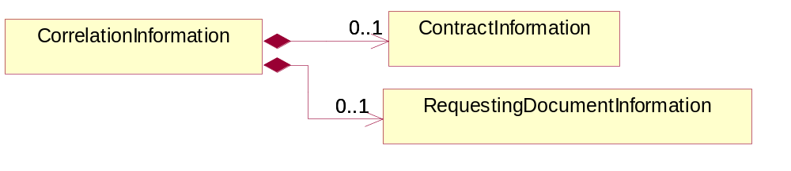
Figure ‎5-36 CorrelationInformation

Composition | Cardinality | Type | Documentation
ContractInformation | 0..1 | ContractInformation | A block of information used to correlate a contract in an executing choreography.
RequestingDocumentInformation | 0..1 | RequestingDocumentInformation | A block of information used to correlate a requesting document to a responding document in an executing choreography.

DocumentHeader
The object allows for the identification of the sender and receiver of the business document.
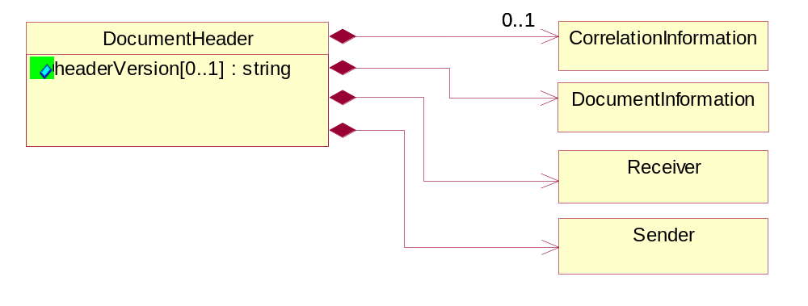
Figure ‎5-37 DocumentHeader

Attribute | Type | Documentation
headerVersion[0..1] | string | The UN/CEFACT version of the document header.

Composition | Cardinality | Type | Documentation
Sender | 1 | Sender | The object allows the identification of the initiating party of the business message.
CorrelationInformation | 0..1 | CorrelationInformation | A block of information used to correlate a requesting document to a responding document and to the contract in an executing choreography.
DocumentInformation | 1 | DocumentInformation | The object specifies information to identify the business document, a summary of attachments, and information about the business document security.
Receiver | 1 | Receiver | The object allows the identification of the receiving party of the business message.

DocumentIdentification
The object specifies all information necessary to identify the business document.
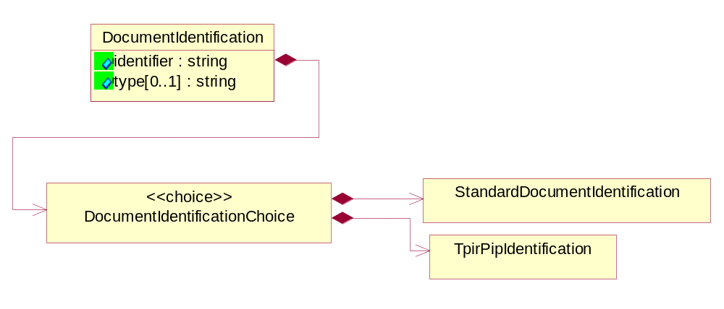
Figure ‎5-38 DocumentIdentification

Attribute | Type | Documentation
identifier | string | The unique identifier for the document being sent.
type[0..1] | string | Name of the Action Message

Composition | Cardinality | Type | Documentation
DocumentIdentificationChoice | 1 | DocumentIdentificationChoice

DocumentIdentificationChoice

Composition | Cardinality | Type | Documentation
StandardDocumentIdentification | 1 | StandardDocumentIdentification | The object specifies additional information necessary to identify the standard business document.
TpirPipIdentification | 1 | TpirPipIdentification | The object specifies all information necessary to uniquely identify a TPIR-PIP within a Registry or trading partner repository.

DocumentInformation
The object specifies information to identify the business document, a summary of attachments, and information about the business document security.
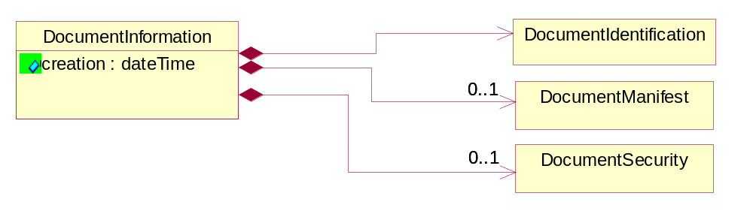
Figure ‎5-39 DocumentInformation

Attribute | Type | Documentation
creation | dateTime | The creation date and time of the specified Business Document (i.e. the Purchase Order date).

Composition | Cardinality | Type | Documentation
DocumentIdentification | 1 | DocumentIdentification | The object specifies all information necessary to identify the business document.
DocumentSecurity | 0..1 | DocumentSecurity | The object provides additional granularity in specifying business document security (this is in addition to the specified PIP security).
DocumentManifest | 0..1 | DocumentManifest | The block provides a brief summary of attachments and Service Content.

DocumentManifest
The block provides a brief summary of attachments and Service Content.
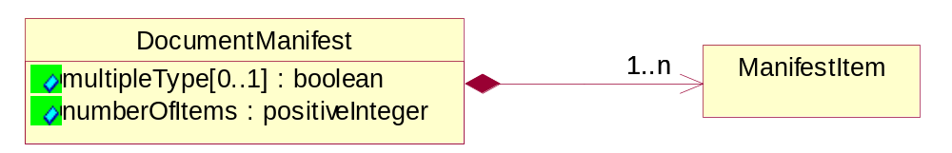
Figure ‎5-40 DocumentManifest

Attribute | Type | Documentation
multipleType[0..1] | boolean | Indicates whether the manifest contains documents of multiple types. True if yes, and False if no.
numberOfItems | positiveInteger | Total number of documents in the message. The physical count of the attachments in the payload plus the RosettaNet Business Message (for Service Content). The value of this field will be at least 1.

Composition | Cardinality | Type | Documentation
ManifestItem | 1..n | ManifestItem | The object provides details about the specific attachment(s).

DocumentSecurity
The object provides additional granularity in specifying business document security (this is in addition to the specified PIP security).

Figure ‎5-41 DocumentSecurity

Attribute | Type | Documentation
nonRepudiableReceipt | boolean | The value "true" will indicate that a signed acknowledgement for the business document is necessary.
persistentEncryption | boolean | The value "true" will indicate that the Business Document (including the header) needs to be encrypted when stored or transported.
persistentSignature | boolean | The value "true" will indicate that a signature is required to be stored with the document while stored or transported.

ManifestItem
The object provides details about the specific attachment(s).

Figure ‎5-42 ManifestItem

Attribute | Type | Documentation
description[0..1] | string | A description of the attachment.
length[0..1] | positiveInteger | The size of the attachment in bytes (i.e. 1 000 000 bytes)
universalResourceIdentifier | string | The generic set of all names/addresses that are short strings that refer to resources.

Composition | Cardinality | Type | Documentation
mimeTypeQualifier | 1 | MimeTypeQualifier | The MIME type as defined by IANA.  Please refer to http://www.iana.org/assignments/media-types/ for a list of types.
language | 0..1 | Language | For representation of Language name RosettaNet has adopted ISO 639-2; 1998. Refer to the following web page to get the latest version of the standard:  http://www.loc.gov/standards/iso639-2/iso639jac.html  If you need more information about the ISO standard please contact ISO for more details.

PipIdentifier
PIP Identification.[ i.e. PIP3A4]
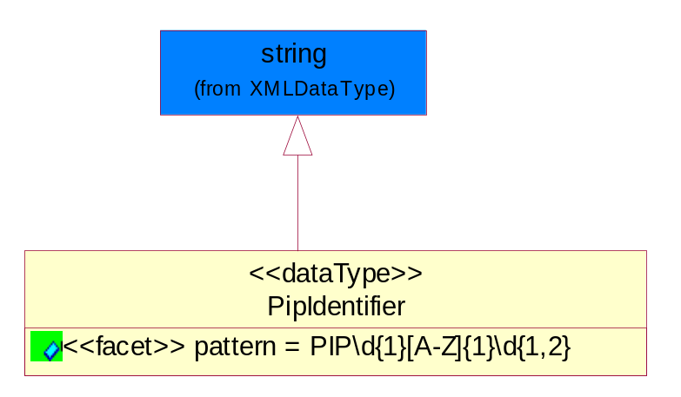
Figure ‎5-43 PipIdentifier

Attribute | Type | Documentation
pattern |  | PIP\d{1}[A-Z]{1}\d{1,2}

PipVersion
PIP version number (i.e. 02.02.00).
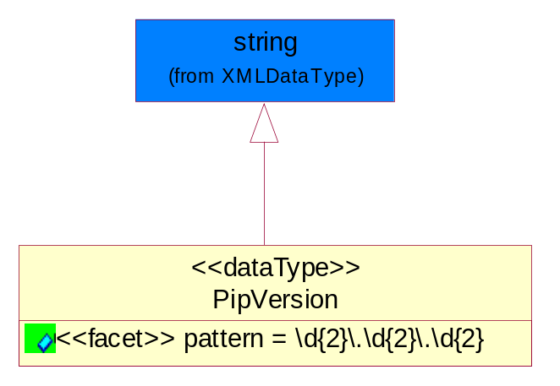
Figure ‎5-44 PipVersion

Attribute | Type | Documentation
pattern |  | \d{2}\.\d{2}\.\d{2}

Receiver
The object allows the identification of the receiving party of the business message.
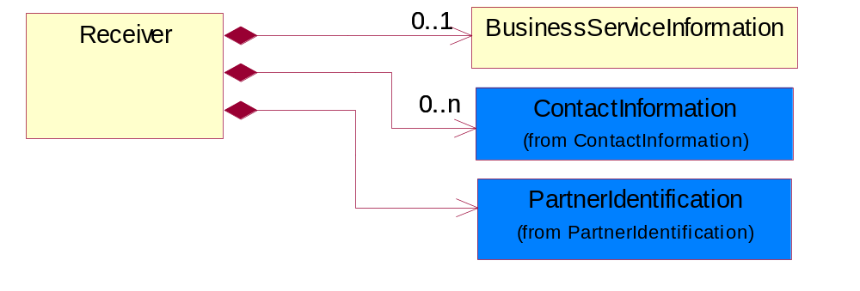
Figure ‎5-45 Receiver

Composition | Cardinality | Type | Documentation
BusinessServiceInformation | 0..1 | BusinessServiceInformation | The object allows the specification of the business service utilized within the partner company. This may or may not be the same as the information sent by the RNIF.
PartnerIdentification | 1 | PartnerIdentification | The business document must allow for the identity of one or more parties to the transaction.
ContactInformation | 0..n | ContactInformation | The business document must allow for the identification of the name of the department, service or individual to be contacted regarding the context of the business document.

RequestingDocumentInformation
A block of information used to correlate a requesting document to a responding document in an executing choreography.

Figure ‎5-46 RequestingDocumentInformation

Attribute | Type | Documentation
businessProcessInstanceIdentifier[0..1] | string | The identifier for the public business process instance being sent that both the sender and receiver can identify.
responseDateTime[0..1] | dateTime | The expected time to receive the response. This can not be greater than the PIP TimeToPerform.
requestingDocumentCreationDateTime[0..1] | dateTime | The date-time of the requesting business document.
requestingDocumentInstanceIdentifier | string | The Business Document identification number that identifies the requesting Business Document.

Sender
The object allows the identification of the initiating party of the business message.
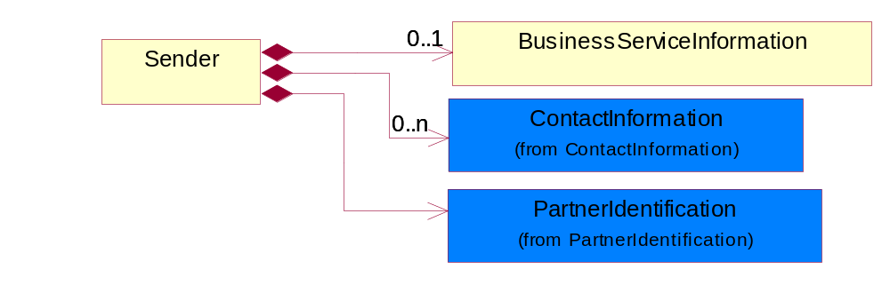
Figure ‎5-47 Sender

Composition | Cardinality | Type | Documentation
PartnerIdentification | 1 | PartnerIdentification | The business document must allow for the identity of one or more parties to the transaction.
BusinessServiceInformation | 0..1 | BusinessServiceInformation | The object allows the specification of the business service utilized within the partner company. This may or may not be the same as the information sent by the RNIF.
ContactInformation | 0..n | ContactInformation | The business document must allow for the identification of the name of the department, service or individual to be contacted regarding the context of the business document.

StandardDocumentIdentification
The object specifies additional information necessary to identify the standard business document.
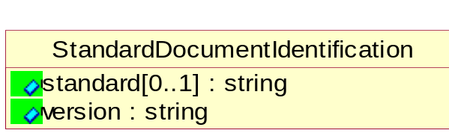
Figure ‎5-48 StandardDocumentIdentification

Attribute | Type | Documentation
standard[0..1] | string | Identifies the standard used to submit the business document. (e.g. RosettaNet).
version | string | PIP3A4v01.00

TpirPipIdentification
The object specifies all information necessary to uniquely identify a TPIR-PIP within a Registry or trading partner repository.

Figure ‎5-49 TpirPipIdentification

Attribute | Type | Documentation
partnerId | DUNSPlus4 | The Trading Partner Identification of MNC that is creating this TPIR PIP.
pipIdentifier | PipIdentifier | A TPIR PIP Identification [i.e., 3A4 ).
pipVersion | PipVersion | A TPIR PIP version number (i.e., 02.02.00)
tpirPipVersion | VersionIdentifier | A TPIR-PIP Version Number (i.e., major and minor version number as XX.XX).
tpirBusinessProcessIdentifier[0..1] | BusinessProcessIdentifier | A Business Process Identifier to uniquely define the TPIR-PIP 'role' within a Business Scenario at a company or MNC level. The identifier MUST be composed of alphanumeric characters only and its length MUST be between one and twelve characters.
uri[0..1] | anyURI | Describes the destination uri for the TPIR form.

Composition | Cardinality | Type | Documentation
fileType | 0..1 | TPIRFileType | Describes the file type of the TPIR form (PDF, XDP or XML).

VersionIdentifier
Version Number (i.e., major and minor version number as XX.XX).
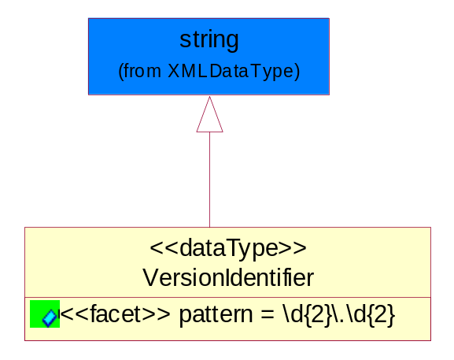
Figure ‎5-50 VersionIdentifier

Attribute | Type | Documentation
pattern |  | \d{2}\.\d{2}

CodeList

TPIRFileType
A code identifying the file type of TPIR form.

Name | Documentation
PDF | Portable Document Format.
XDP | XML Data Package.
XML | eXtensible Markup Language.

XML Data Type

anyURI
Represents a URI as defined by RFC 2396. An anyURI value can be absolute or relative, and may have an optional fragment identifier.

boolean
Represents Boolean values, which are either "true" or "false".

dateTime
Represents a specific instance of time.
The pattern for dateTime is CCYY-MM-DDThh:mm:ss where CC represents the century, YY the year, MM the month, and DD the day, preceded by an optional leading negative (-) character to indicate a negative number. If the negative character is omitted, positive (+) is assumed. The T is the date/time separator and hh, mm, and ss represent hour, minute, and second respectively. Additional digits can be used to increase the precision of fractional seconds if desired. For example, the format ss.ss... with any number of digits after the decimal point is supported. The fractional seconds part is optional.

This representation may be immediately followed by a "Z" to indicate Coordinated Universal Time (UTC) or to indicate the time zone. For example, the difference between the local time and Coordinated Universal Time, immediately followed by a sign, + or -, followed by the difference from UTC represented as hh:mm (minutes is required). If the time zone is included, both hours and minutes must be present.

positiveInteger
Represents an integer that is greater than zero. This data type is derived from nonNegativeInteger.

string
Represents character string.

